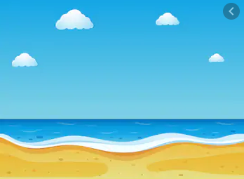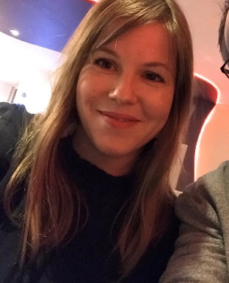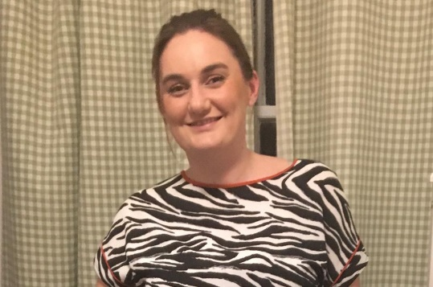
Post Card
Hello Year One,
How are you all? We are missing you lots!
We hope you have enjoyed the learning
We sent you? Thank you for all your
lovely pictures! Remember some of the
learning we had only just started so don’t
worry if you find it tricky! Both of us have
eaten a LOT of Easter eggs and can’t wait
to see all your lovely smiling faces!
Mrs Solomon and Mrs Sykes

