Home Learning
Year 5 – Summer Term 5 Week 2
27th April 2020
Comprehension:
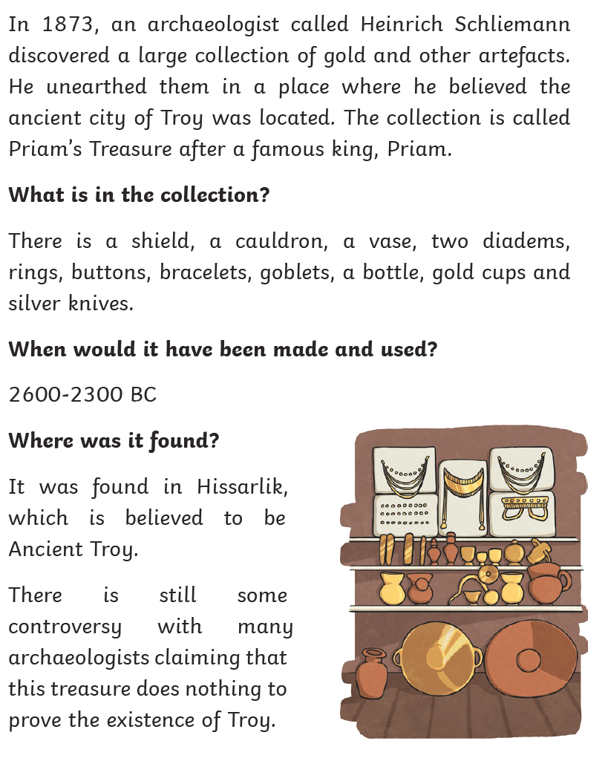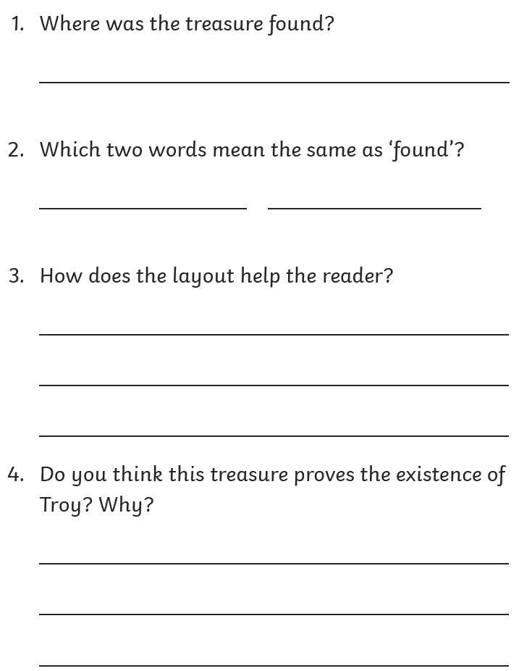

English:
Grammar –
Can you remember what a subordinate conjunction and a subordinate clause are?
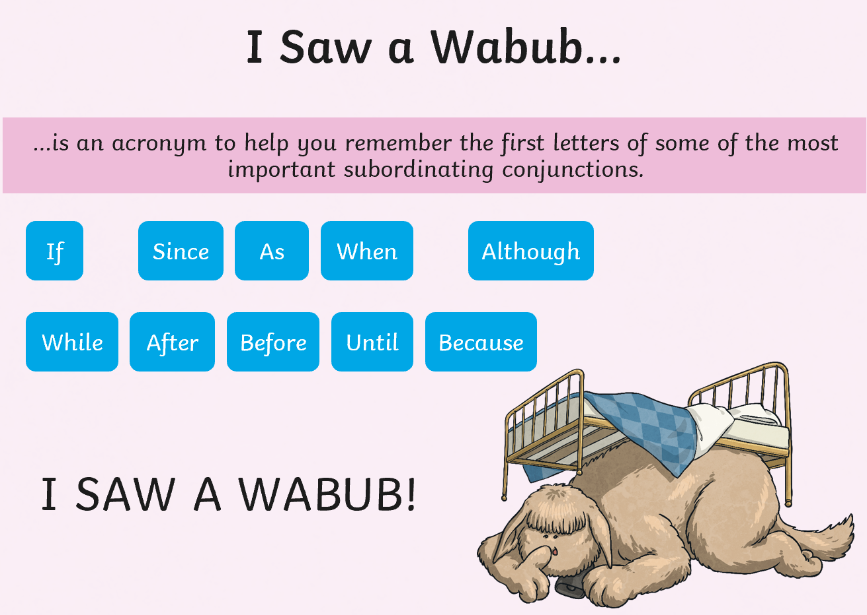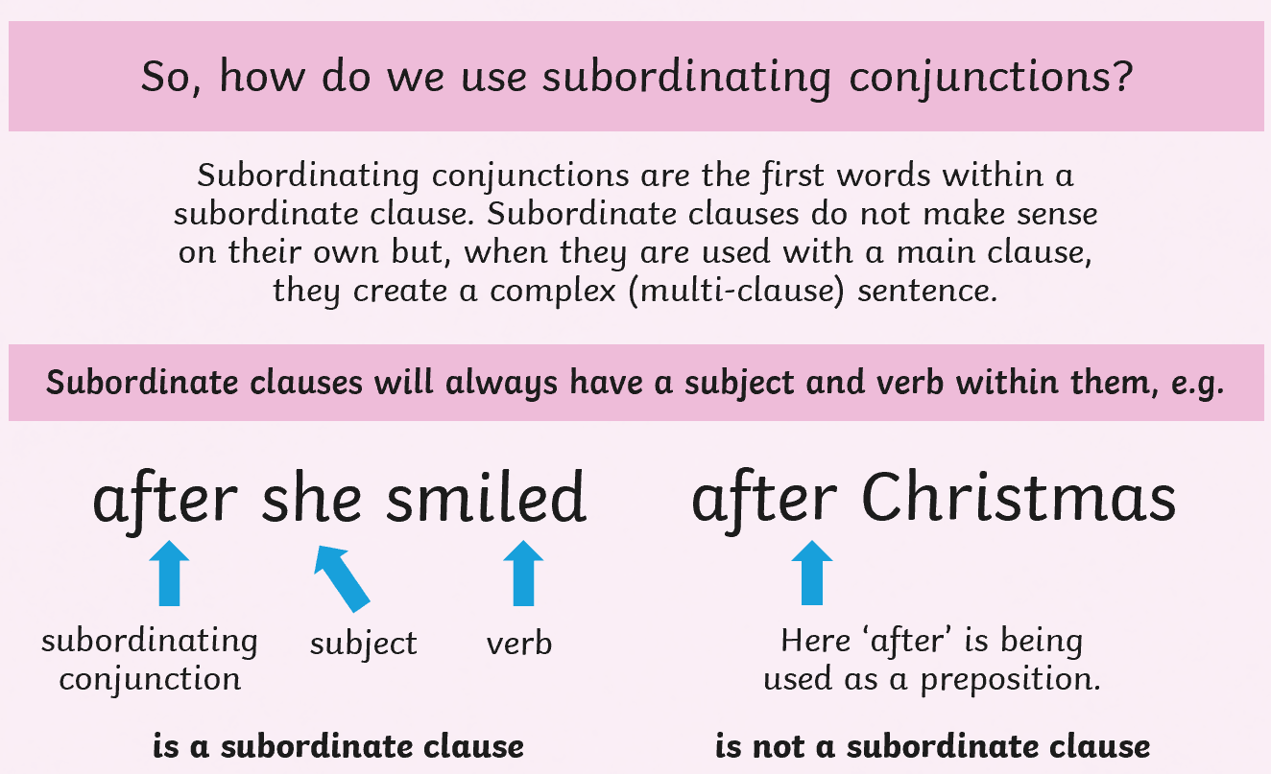
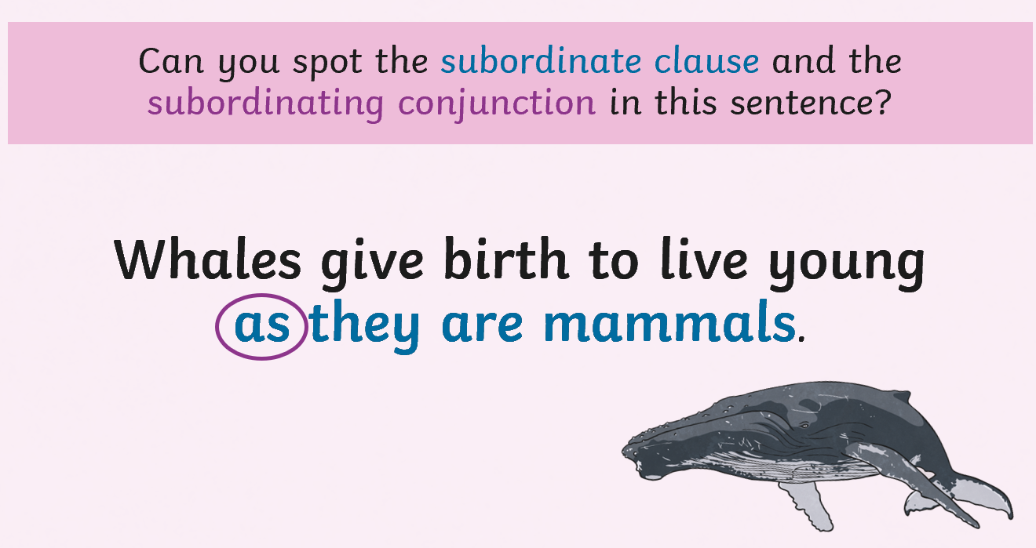
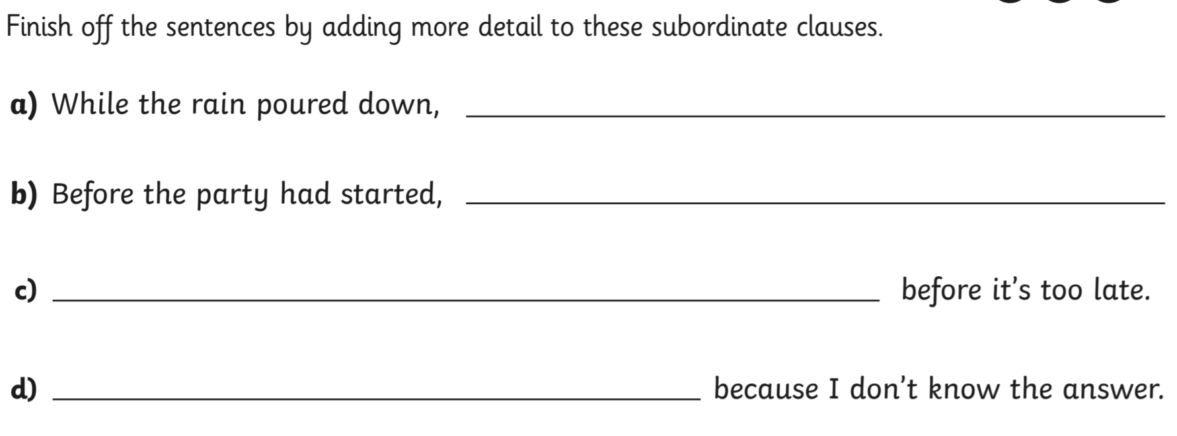

Challenge:
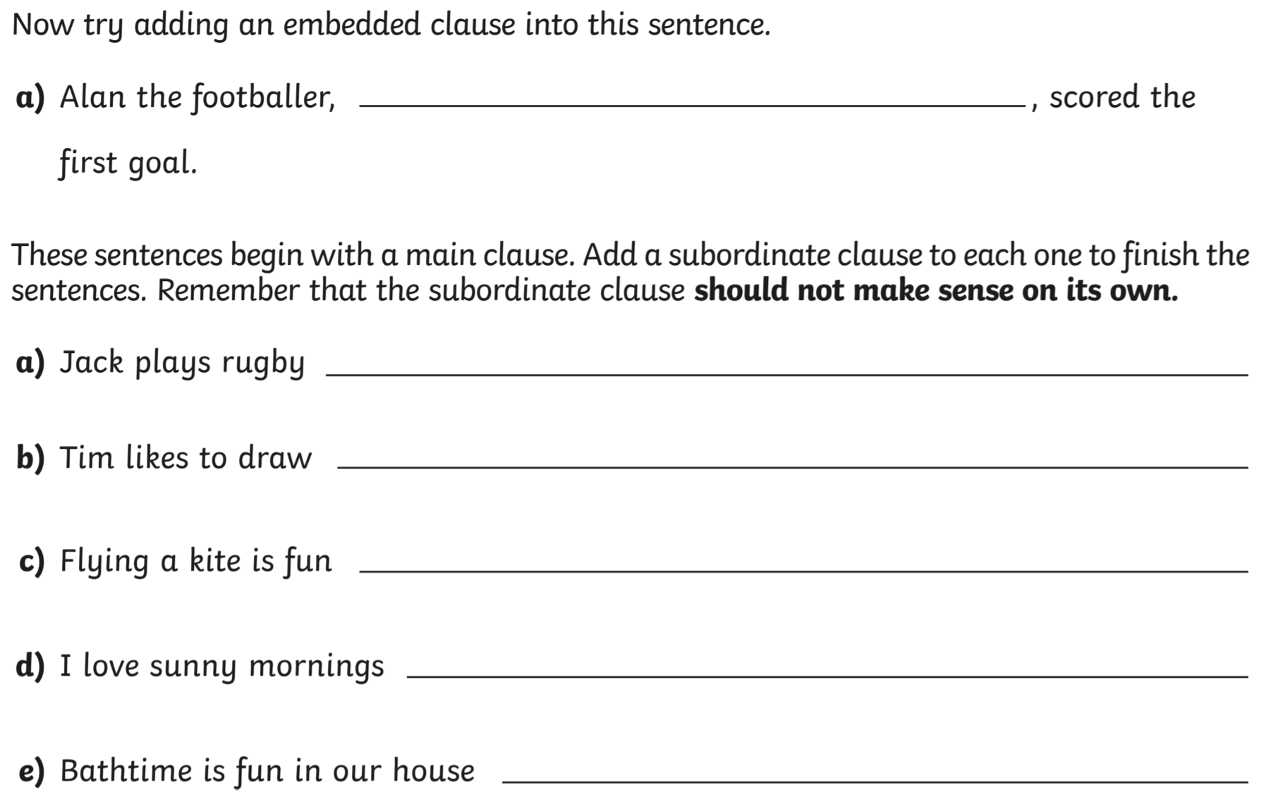

Writing – setting description

Write a description of the events in the picture. See if you can use subordinate clauses in your writing.

Although the boys were terrified at the thought of falling, they were excited to see the landscape through the clouds.

Challenge: Can you include expanded noun phrases in your writing?

The white, wispy clouds lay beneath their feet.

Extra challenge: Perhaps you could use similes, metaphors or personification.
.
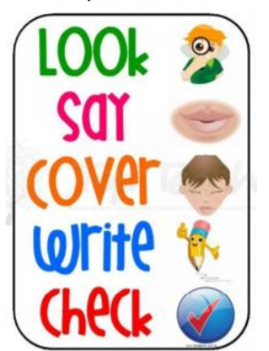
Spellings:
Mrs Wood’s group | Mrs Sloan and Mrs Valentine’s group | Mrs Wahl’s group
plough  bough  drought  brought  bought  wrought  thought  ought  borough | return  refresh  reappear  repeat  remember  reapply  repay  rebuild | know  year  our  help  think  give  tell  three  man

Try the segmentation spelling strategy
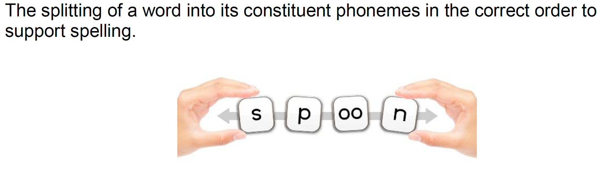

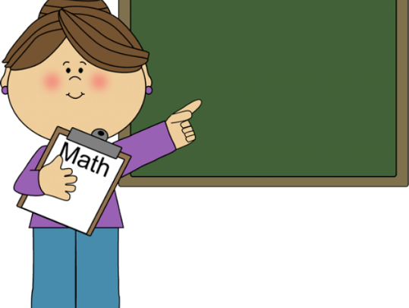
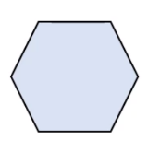
Maths:
Maths

Do you know what this shape is called?
Flashback 4!
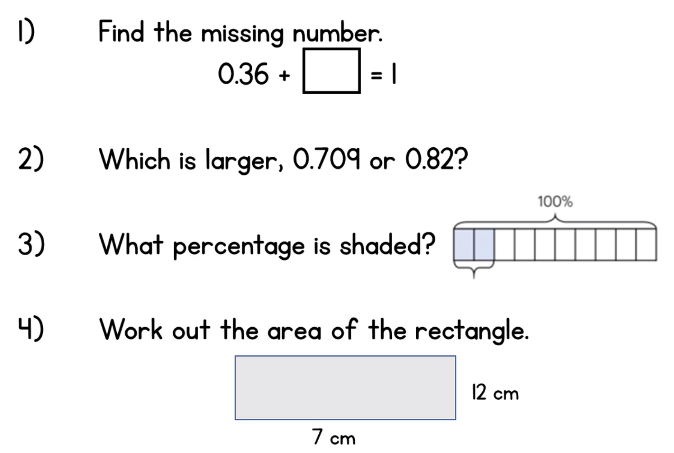

WRH Sumer Term Week 2 - Adding and Subtracting Decimals
Look at the WRH website https://whiterosemaths.com/homelearning/year-5/ Summer Term week 2 for all of the lessons and questions on adding and subtracting decimals. Each day you will find an easy to follow video tutorial with questions to work out.
When you have completed the lessons for the week, have a go at the 20 assessment questions on Professor Assessor. I will then be able to see how you are getting on.
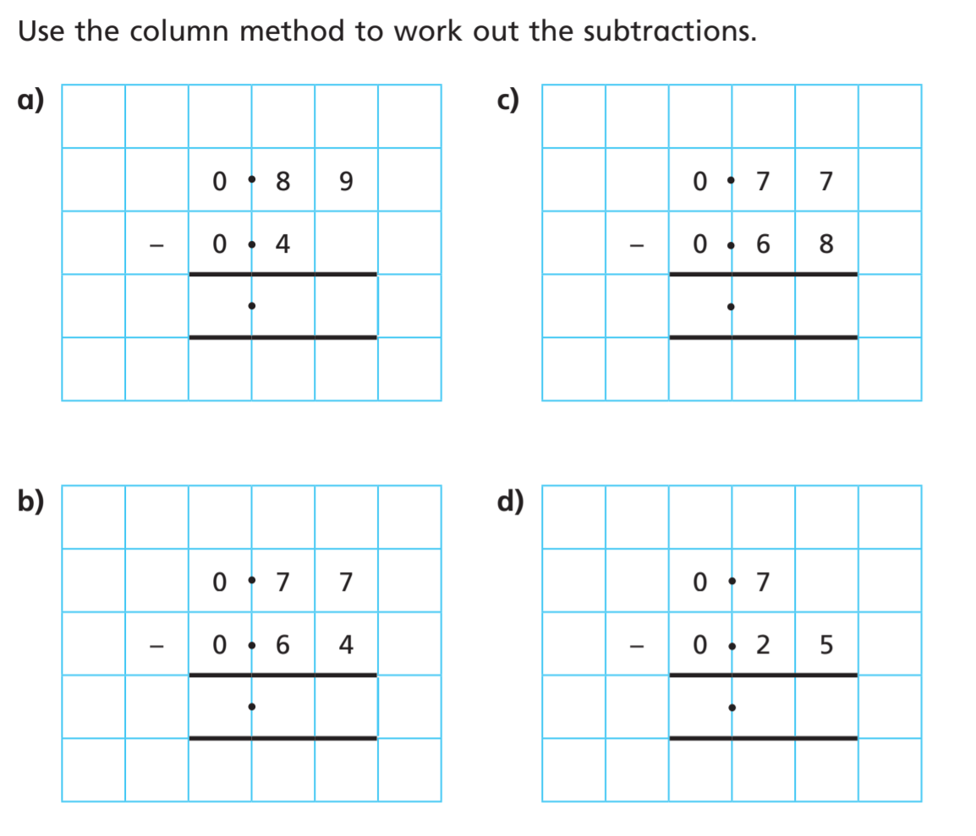
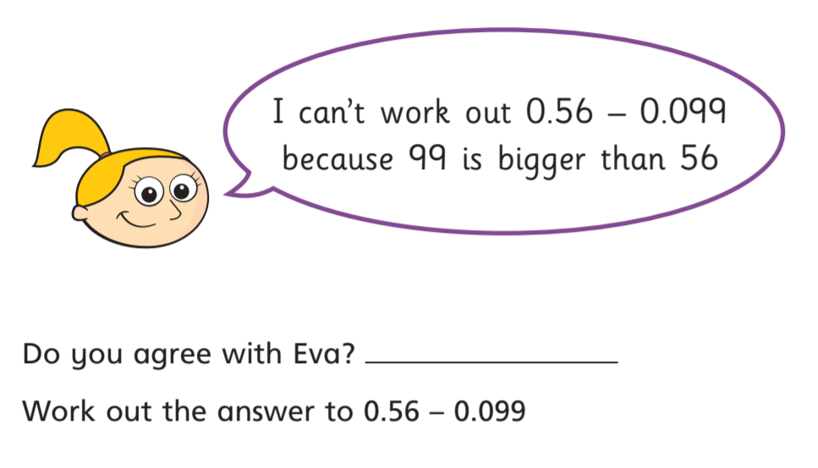
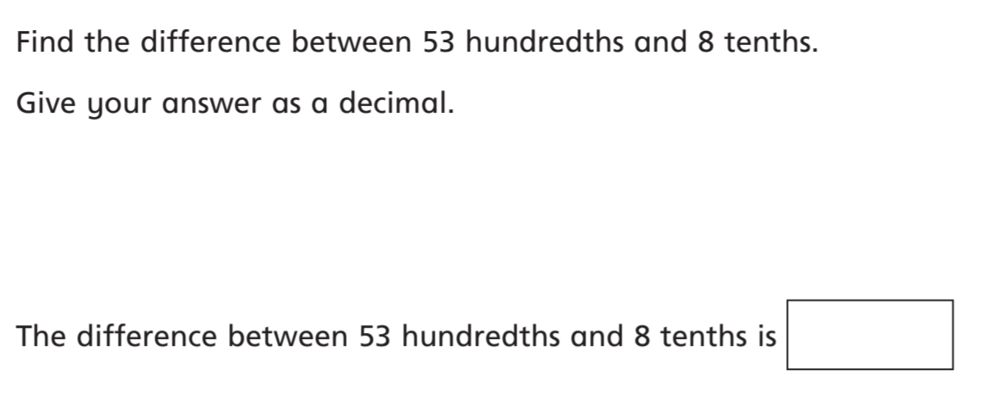

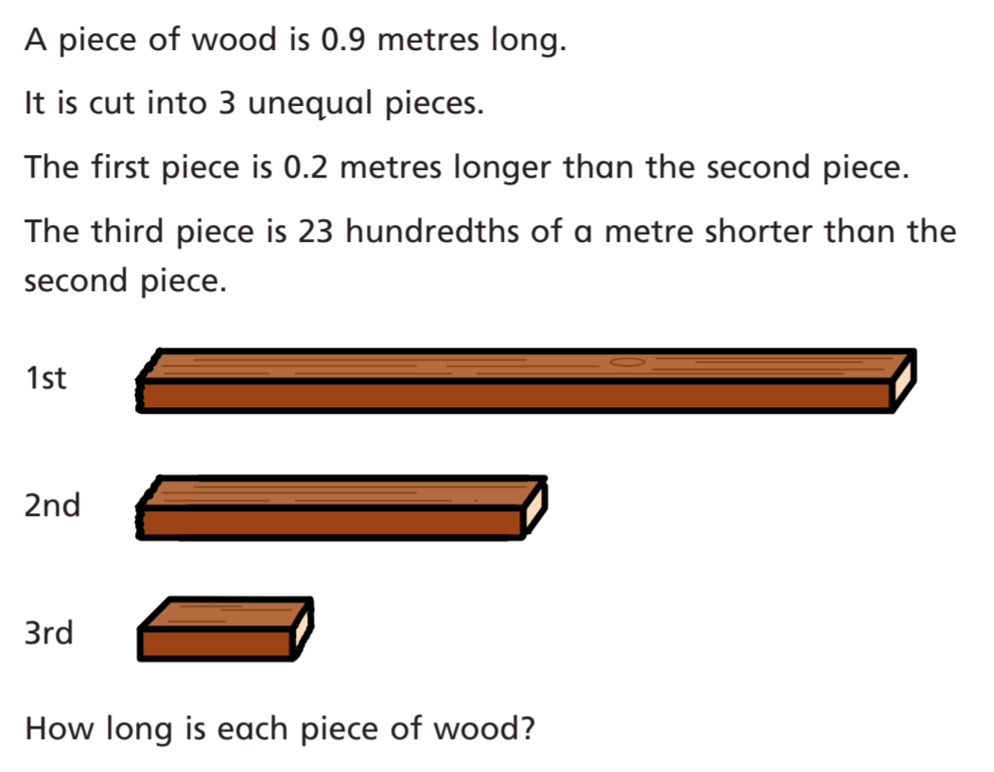

Science:
Either or
Find out about pollination and make a fact file.
- What is pollination?
- What can you find out about wind and insect pollination?
- Can you give examples of plants that are wind and insect pollinated?
- How is each part of the flower adapted for wind or insect pollination?

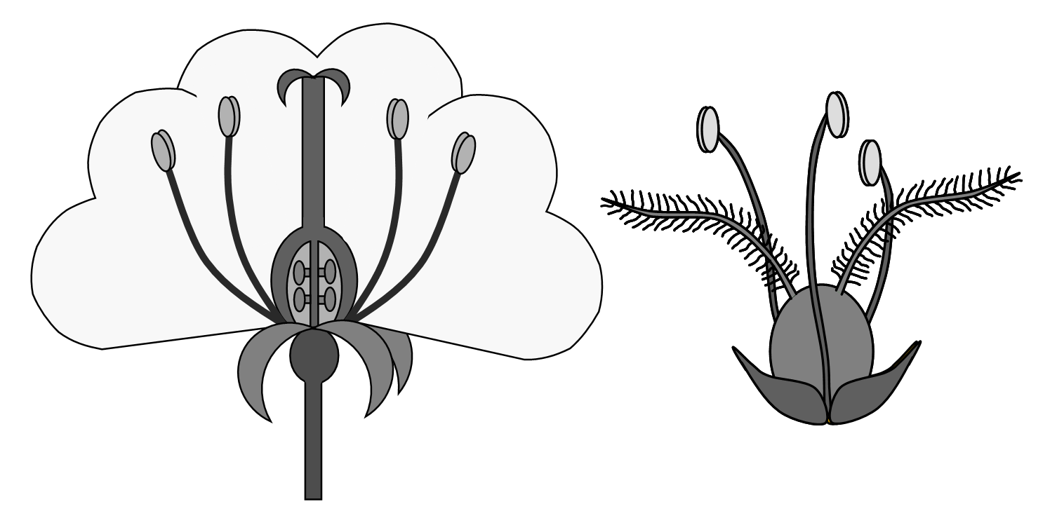
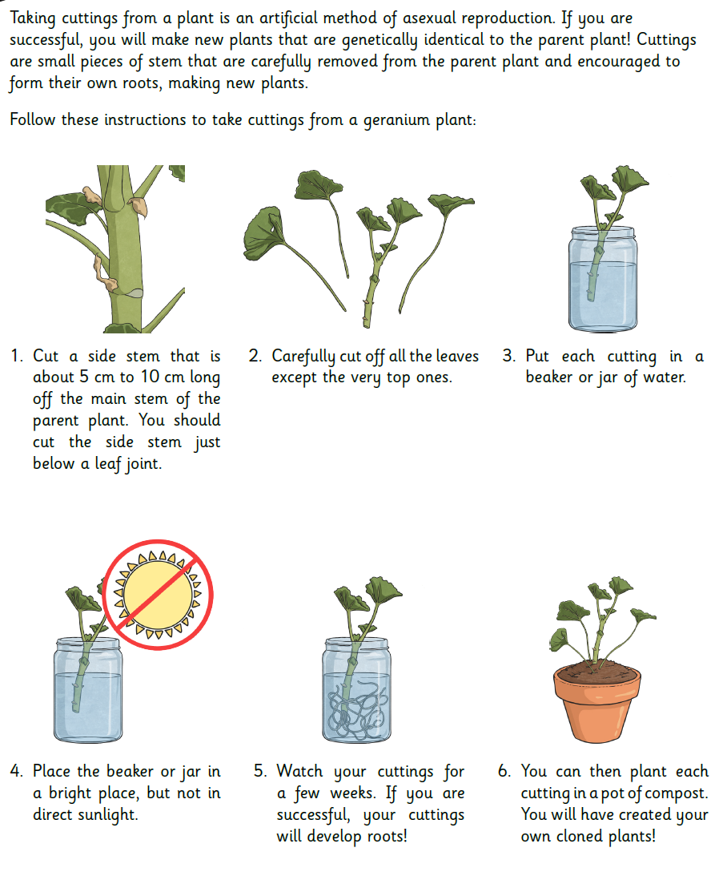
- There are lots of other plants that you could propagate from cuttings. If you are lucky enough to have a grandparent who is a keen gardener, perhaps you could call them on the telephone and ask them for some advice.
History:
Last term we started to learn about the Mayan Civilisation.
Read the fact sheets below to remember who the Mayan’s were and where they lived.
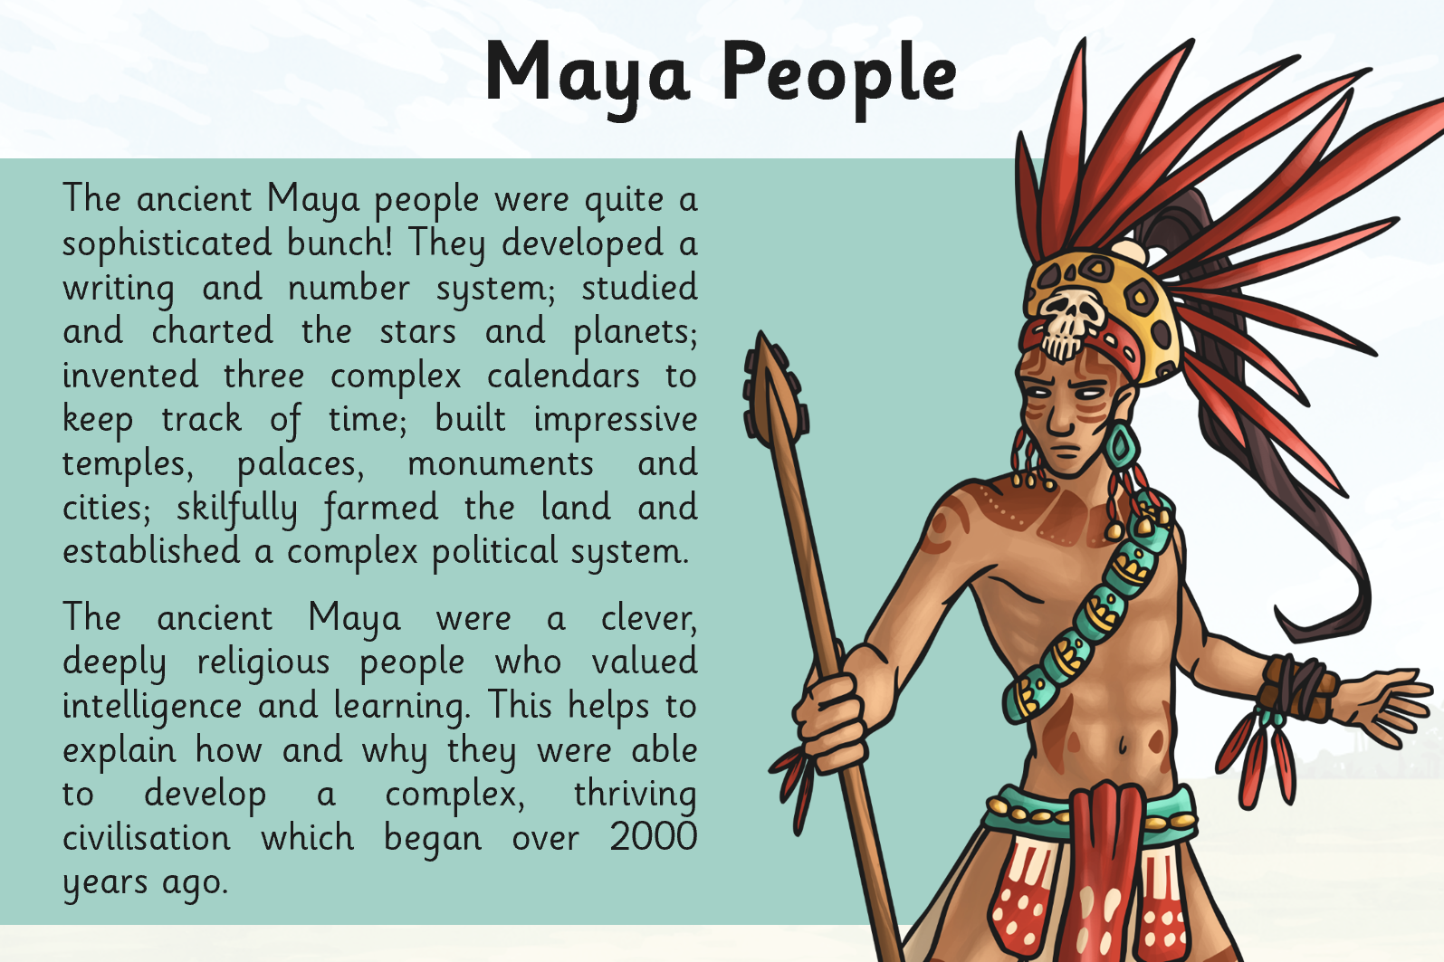
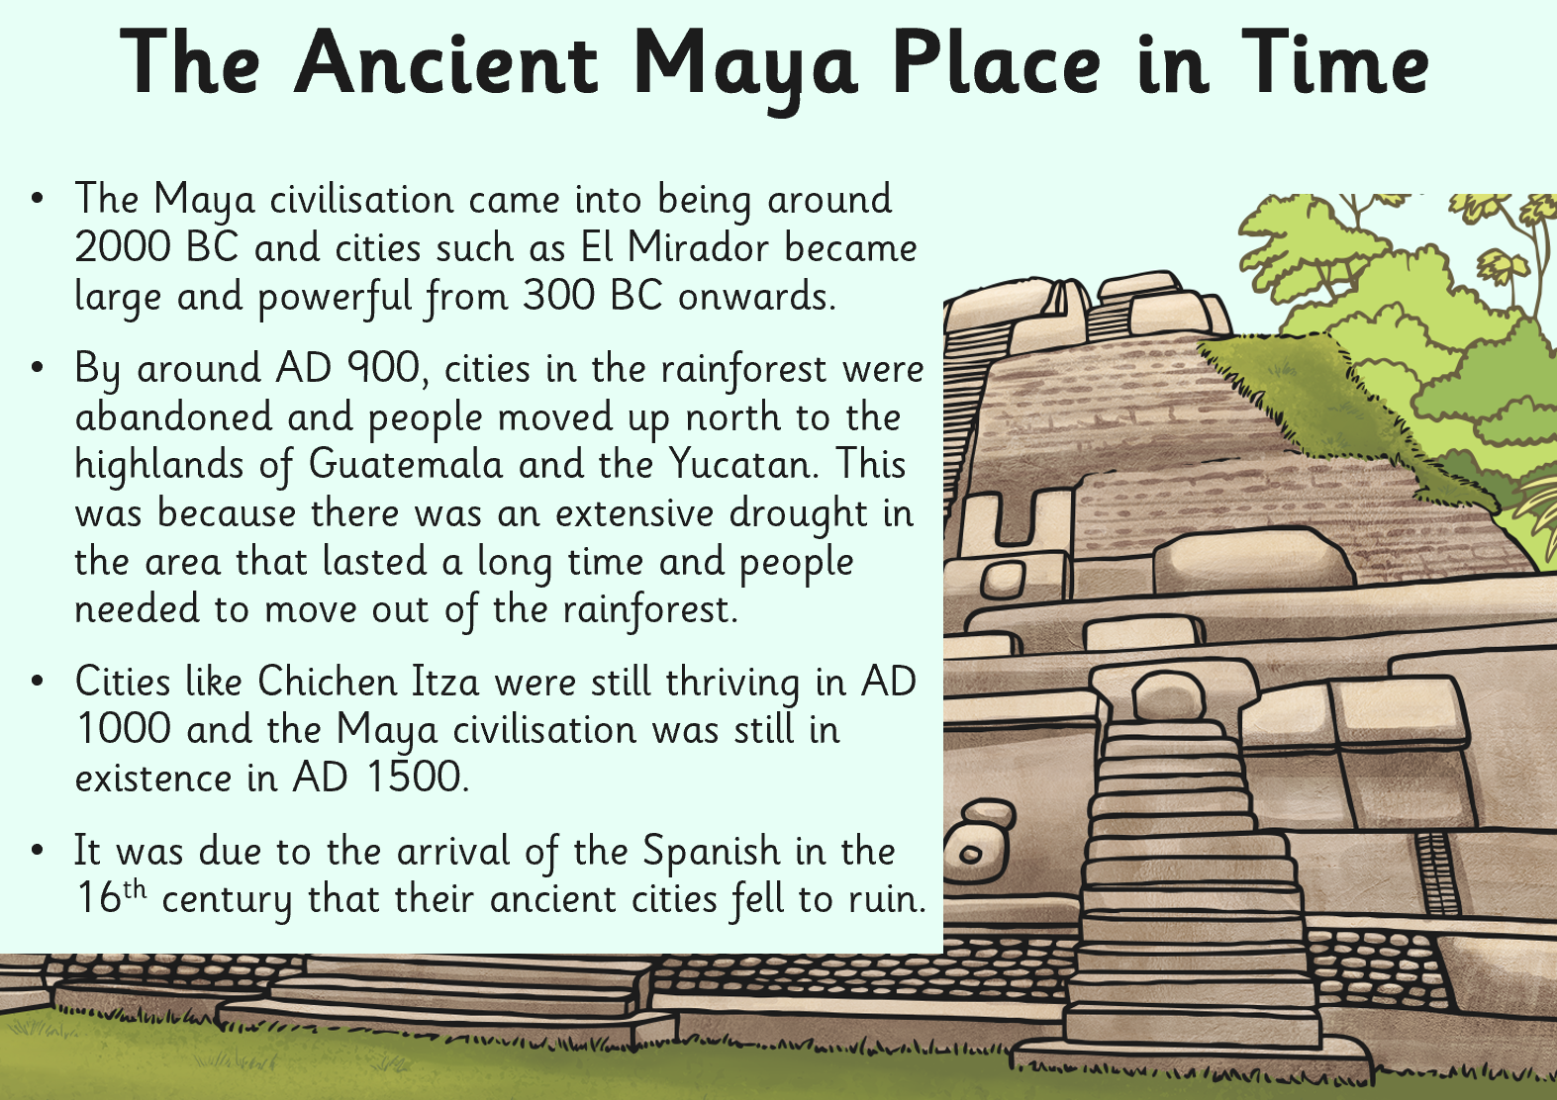
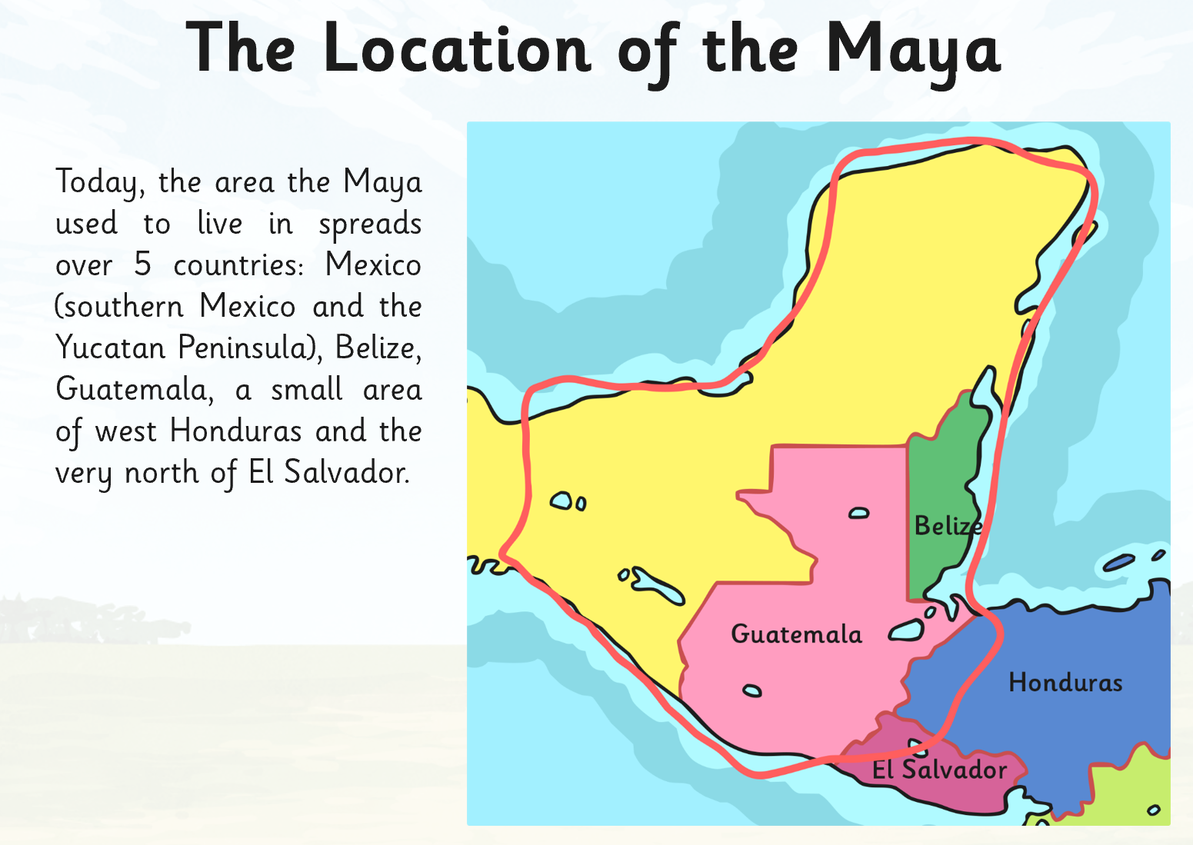
Look on Google Earth or an atlas to see if you can find where these countries are.
Challenge: Can you find out where some of the ancient cities would have been?

Geography:
Use the internet or an atlas to find out where these famous volcanoes are in the world.
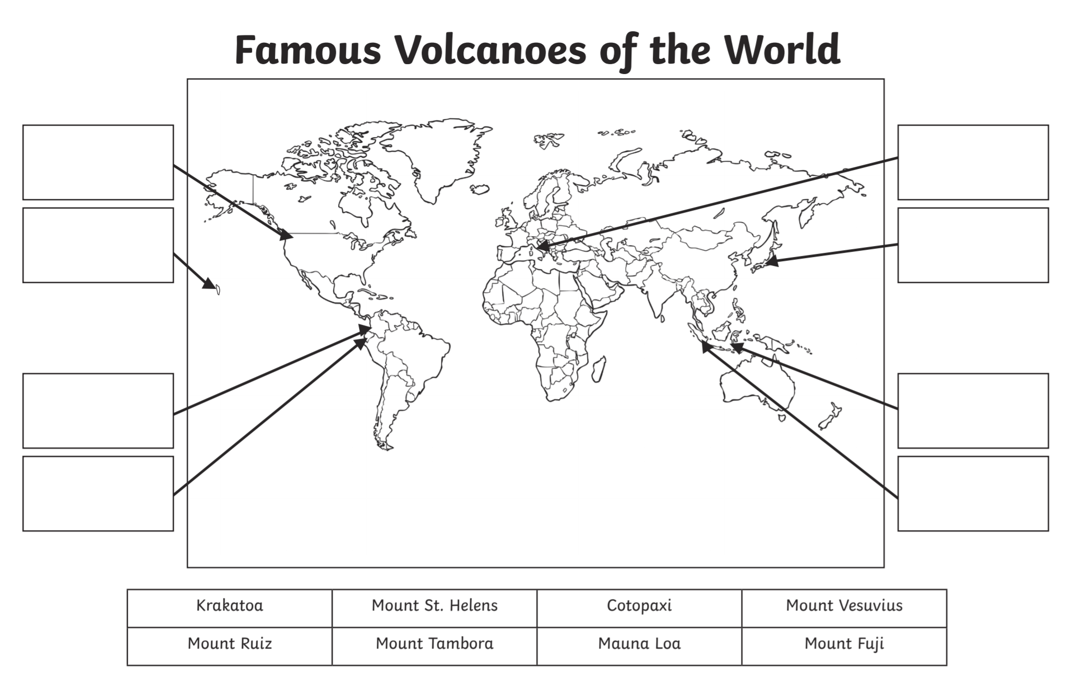

Art:

RE:
Write some lyrics to a new Easter hymn to the tune of a well-known nursery rhyme or your favourite hymn tune.

Languages:
- Can you write down the numbers from 1 to 10 in French? Can you then teach someone in your home how to say these words?

Times Tables:
- Login to Professor Assessor to practise your times tables.

PE
- Visit The Body Coach TV YouTube channel each morning at 9am as he will be providing a live PE at home lesson.
https://www.youtube.com/channel/UCAxW1XT0iEJo0TYlRfn6rYQ

Mindfulness
- Need a time out? Go online to Cosmic Kids Yoga and follow a guided relaxation video @ https://www.youtube.com/user/CosmicKidsYoga

Useful Websites:
https://www.thenational.academy/- an enterprise set up by teachers and funded by the DfE which provides video lessons for pupils daily - from Reception to Year 10 - each lesson comes with a corresponding quiz and worksheet. Lessons last about an hour.
https://www.bbc.co.uk/bitesize/articles/z6vpnrd- building on their Bitesize website, there are daily lessons for every year group and every subject. There are also some guest star teachers such as David Attenborough and Jodie Whittaker.
https://www.prof123.co.uk/Children should have their login details
https://www.topmarks.co.uk/ - Maths and English interactive activities
https://www.youtube.com/user/GoNoodleGames - Physical activities
https://spellingframe.co.uk/ - Spelling Practice (There are free games – no signup needed)
https://mathsframe.co.uk/ - Maths Practice (There are free games – no signup needed)
https://www.nhs.uk/change4life/recipes - Cooking Ideas

