**Home Learning**

**Year 5 – Summer Term 6 Week 1**

**1st June 2020**

# English

# Instructions

# This week I would like you to continue to use the video tutorials on the Oak Academy website for your English lessons.

# <https://www.thenational.academy/online-classroom/year-5/english#subjects>

# Year 5 teachers will lead you through your learning each day and will teach you about reading comprehension, grammar and writing techniques.

# I hope that you enjoyed your lessons with Mrs. Barr, Mr. Emmerson and Mrs. Blake last week. I look forward to seeing your diaries in your workbooks when you return to school. This week you will be asked to write a set of instructions. You will be able to use some of the grammar and writing techniques that you have already used in year 5. On Monday, Mr Emerson will teach you about finding answers in reading comprehension activities and he will give you your spellings for the week, which are the spellings for Mrs. Wood’s group. Mrs Barr will test you on your spellings on Friday.

# If you are not able to use a computer to take part in the online video tutorials, please complete the activities below.

# Reading Comprehension

# 

# Grammar: Conjunctions

# 

# 

# Writing – Instructions

# A set of instructions are a sequence of steps in chronological order, which if completed a task/project will have been successfully achieved.

# 

# 

# Look at this WAGOLL (What A Good One Looks Like) of a set of instructions for how to catch a dragon. Can you spot any of the features listed above? Perhaps you could use different coloured highlighter pens to highlight them. Can you also spot any different types of conjunctions?

# 

# 

**Spellings:**

|  |  |  |
| --- | --- | --- |
| Mrs Wood’s group | Mrs Sloan and Mrs Valentine’s group | Mrs Wahl’s group |
| forcibly  legibly  possibly  horribly  terribly  visibly  incredibly  sensibly | young  touch  double  trouble  country  rough  tough  cousin | still  learn  point  animal  listen  land  turn  air |

Spelling Strategy: **Words without vowels**

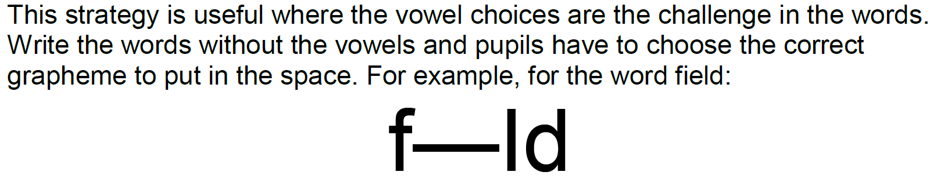

**Maths:**

**Flashback 4!**

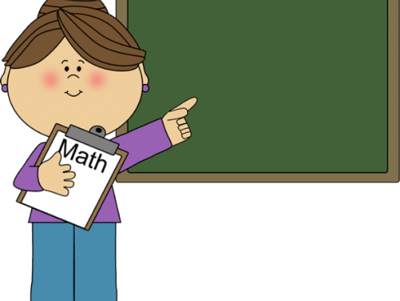

Maths

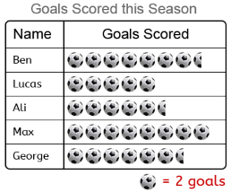

How many goals has Ben scored?

1. £13.21 + £6.18
2. 7 x 8
3. 23 x 42
4. 642 ÷ 3

**WRH Sumer Term Week 6 – Multiplying fractions and fractions of an amount**

Look at the WRH website <https://whiterosemaths.com/homelearning/year-5/> Summer Term week 5 for all of the lessons on fractions. Each day you will find an easy to follow video tutorial with questions to work out. The children in year 5 have already done lots of work on fractions, so this will be useful revision for them. The worksheets can be found in the home learning area of the class page on the school website. Hard copies will also be available from the school office alongside the home learning.

Additional practice questions and worksheets can be found at the BBC Bitesize daily lesson website

<https://www.bbc.co.uk/bitesize/dailylessons>

When you have completed the lessons for the week, have a go at the 20 assessment questions on Professor Assessor. I will then be able to see how you are getting on.

**Science: Different types of rock**

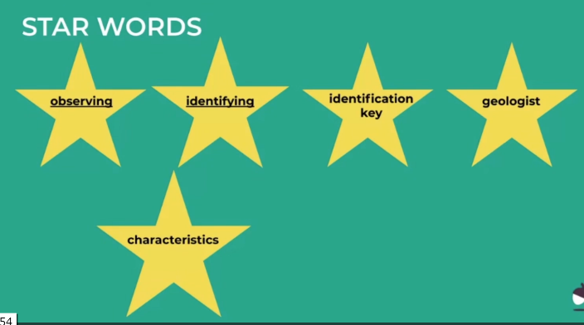Look at the Oak Academy website to find out about how to identify different types of rock. Here are some key words to get you started

<https://www.thenational.academy/year-5/foundation/how-can-we-identify-different-types-of-rock-ear-5-wk4-3#slide-3>

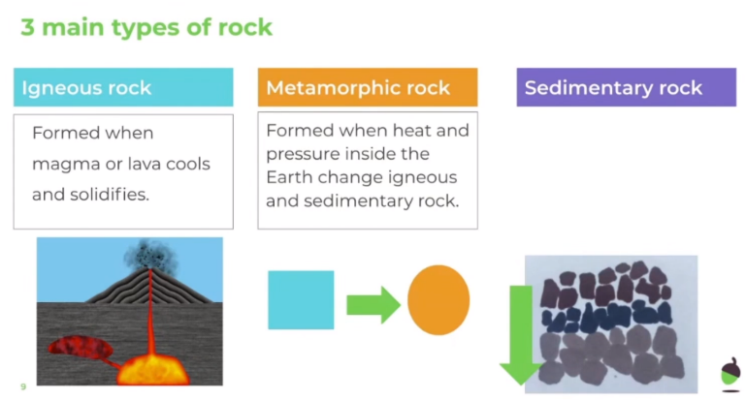

First a quick recap on the different types of rock.

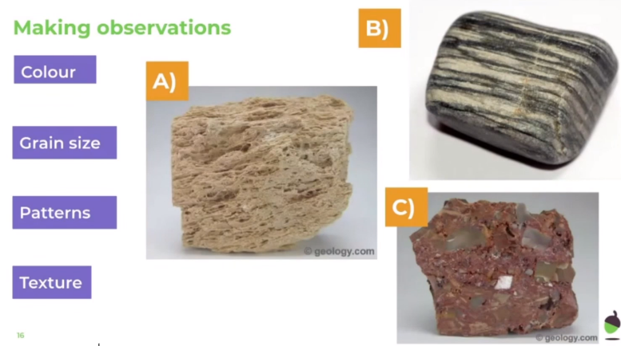Look at these different types of rock. How could you describe them?

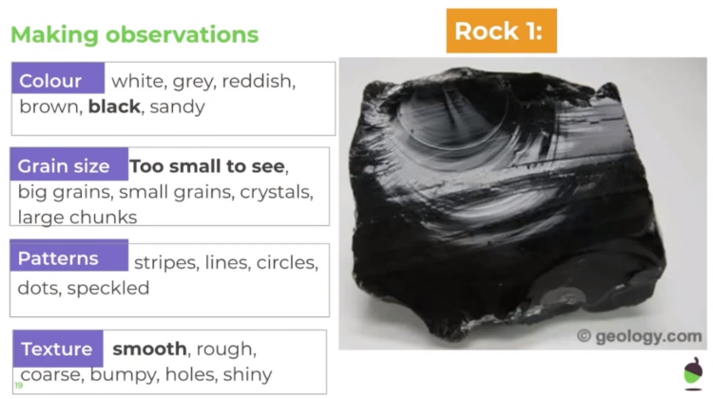

This one has been done for you. It doesn’t really have a pattern, so none of these words have been highlighted.

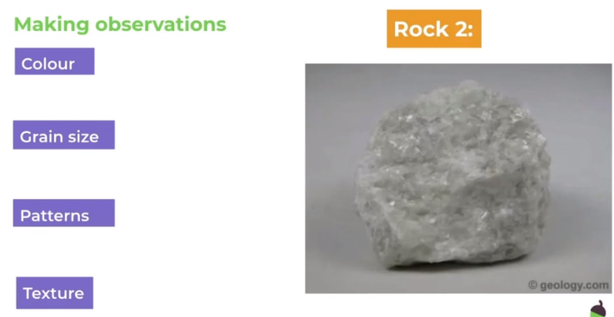

Now your turn, how would you describe this rock? Look at the words on rock 1 to help you.

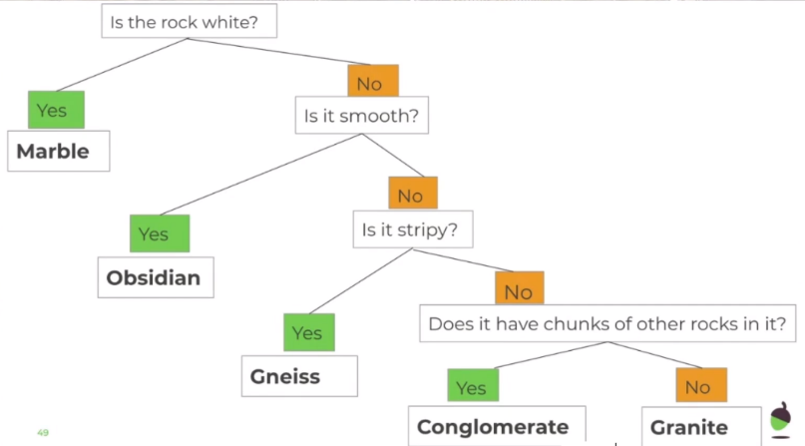

Look for different types of rock in your garden. Make observations to describe them. If you are able to watch the video with Miss Simpkin, she will describe how to make an identification key like the one shown here.

Challenge: Can you find out about the different types of rock shown on the identification key?

**History:**

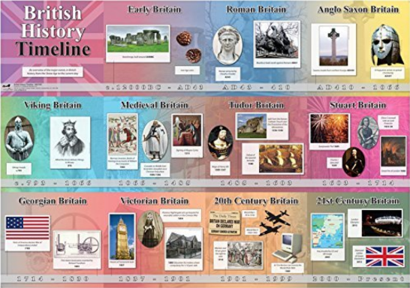This term our topic is about geography. However, if you would like to find out more about history, perhaps you would like to choose your own period in history to find out about. Maybe you would like to find out about the Tudors or what life was like in Britain during the Middle Ages. Other periods in history that you may like to find out about include:

* The Stone Age
* The Stuarts
* The Georgians
* The Victorians
* Modern history
* American history

or the history of another country.

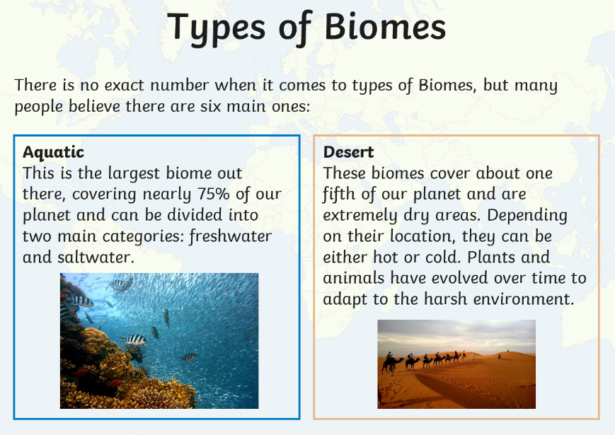**Geography: Biomes**

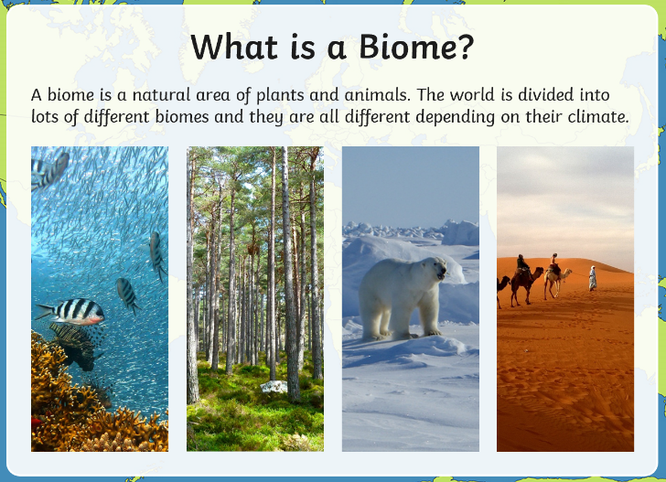

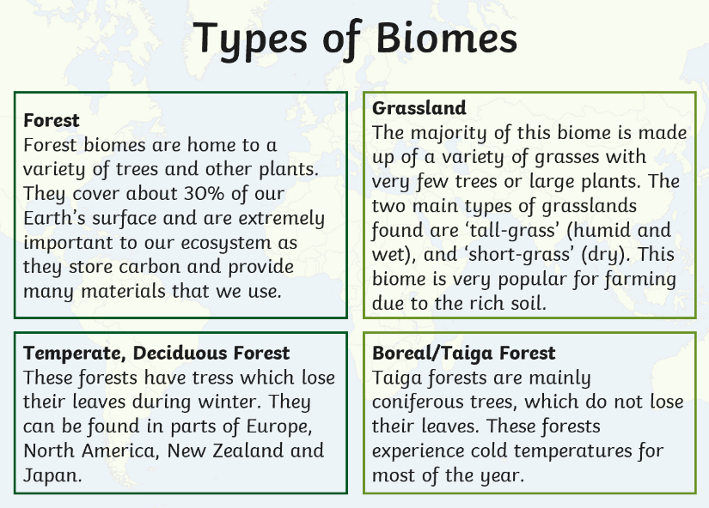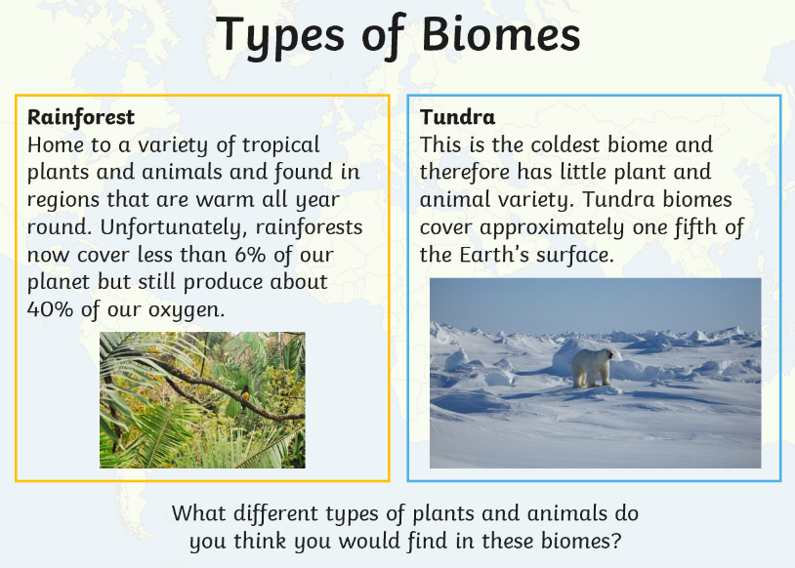

**Geography/Music**

Learn to sing the ‘My Biome’ song. Make sure that you find the song written by Mr Parr, not the Minecraft song!

<https://www.youtube.com/watch?v=0A5eeE93uEA>

I’m very sad that I can’t sing this with you class 5! Perhaps you could ask your family to sing it with you and each take on a different rap section!!

**Art: Portraits**

Either draw a self-portrait or a portrait of a member of your family. You could use pencil crayons, sketching pencils, paints or any other medium that you have at home. I would love to see your finished pictures.

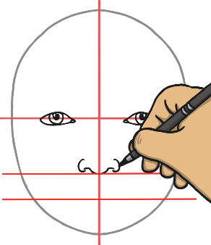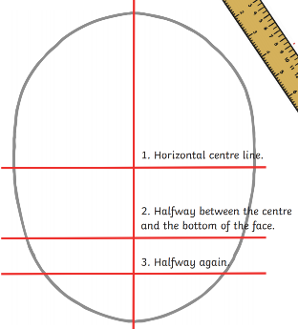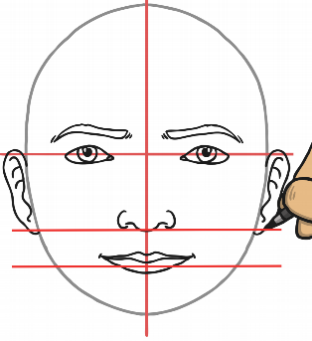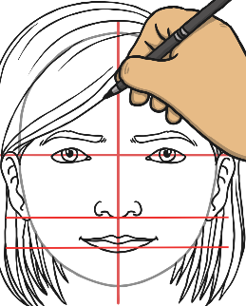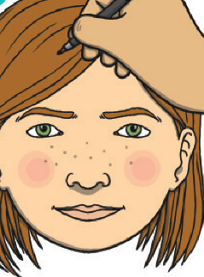

**RE:**

What do you already know about Pentecost? Make a poster / booklet / short film to show what you already know and can remember about Pentecost.

Use the key questions below to prompt your thinking.

* What does Pentecost celebrate? How does this link to Easter?
* Think of at least 5 key words that you think link to Pentecost. Why did you choose them?
* What symbols and images do we associate with Pentecost? Why?
* How does the Catholic Church mark Pentecost Sunday? (Liturgical colour? Bible reading?)
* Which sacrament(s) could you link to Pentecost? Why?
* What was the impact of the first Pentecost Sunday?
* What impact can Pentecost have on Christians today?

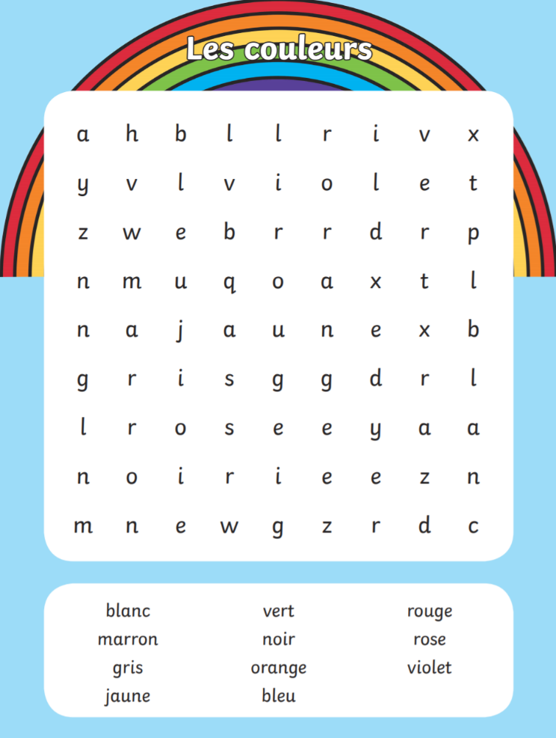**Languages: French colours**

Can you complete the wordsearch to find the names of the colours in French?

See if you can find out how to pronounce them correctly.

**PSHE: Wellbeing**

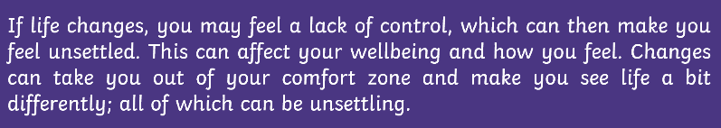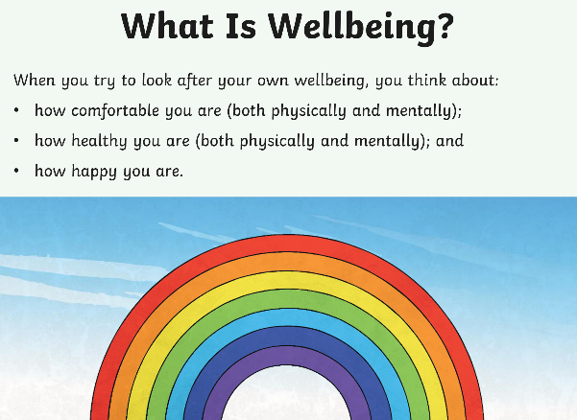

This term we will look at wellbeing in PSHE and think about ways that you can look after your wellbeing, especially in times of change.

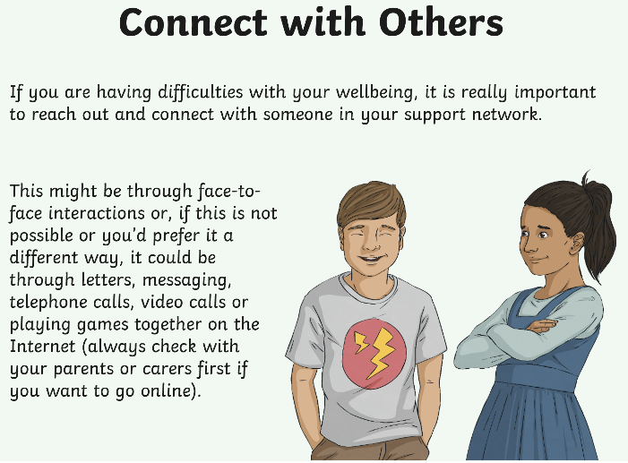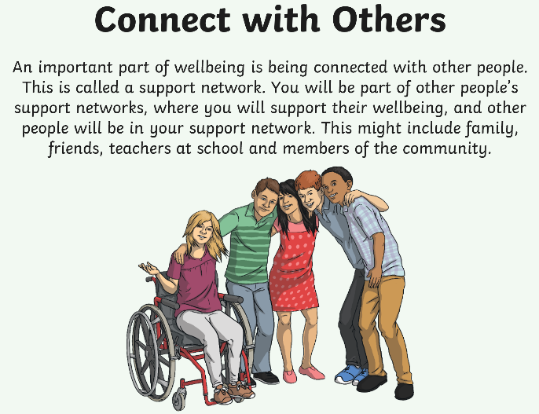

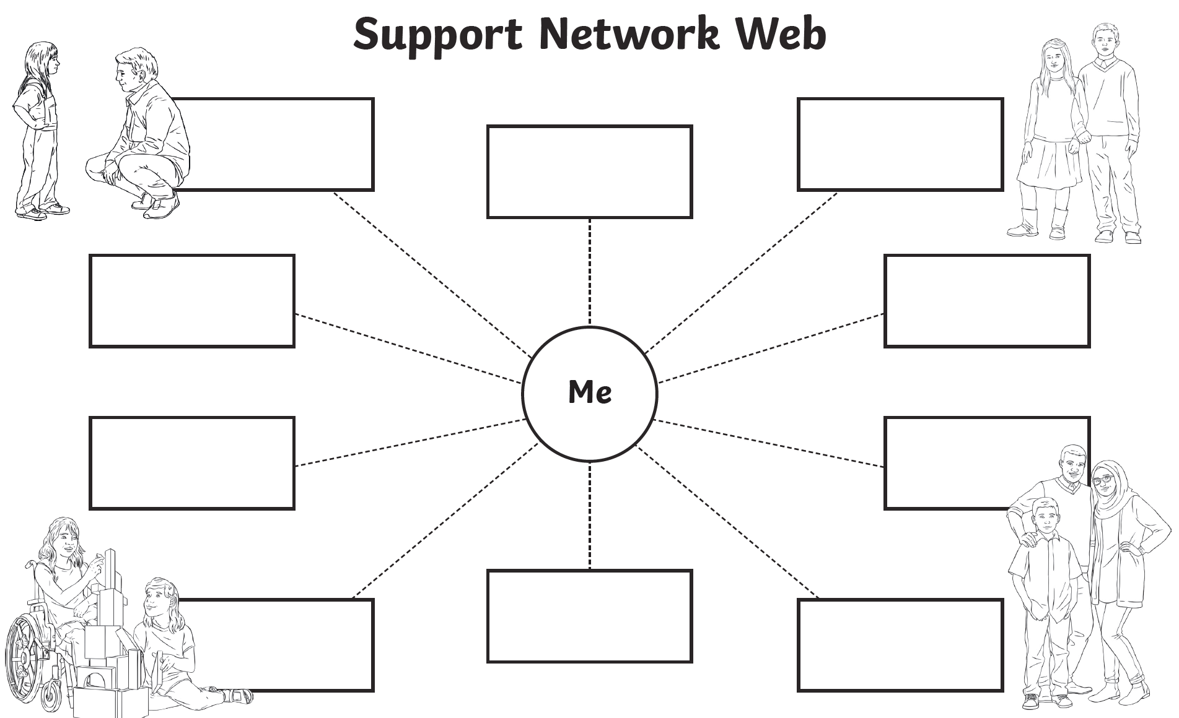

**Times Tables:**

* Login to Professor Assessor to practise your times tables.

**PE**

* Visit *The Body Coach* TV YouTube channel each morning at 9am as he will be providing a live PE at home lesson.

<https://www.youtube.com/channel/UCAxW1XT0iEJo0TYlRfn6rYQ>

**Mindfulness**

* Need a time out? Go online to Cosmic Kids Yoga and follow a guided relaxation video @<https://www.youtube.com/user/CosmicKidsYoga>