Home Learning – Year 6
Week 4 – Answers
Daily Arithmetic Answers:
Monday | Tuesday | Wednesday | Thursday | Friday
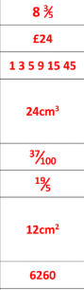 | 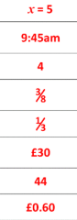 | 24  940  11  0.14  13 3/5  1/6  14m | 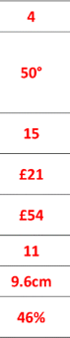 | 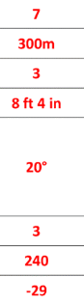

Day 1 Investigation:
