Home Learning
Year 5 – Summer Term 5 Week 3
4th May 2020

English

This week I would like you to use the video tutorials on the Oak Academy website for your English lessons.

https://www.thenational.academy/online-classroom/year-5/english#subjects

Year 5 teachers will lead you through your learning each day and will teach you about reading comprehension, grammar and writing techniques.

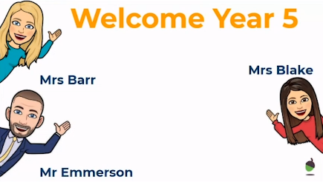
Although the teachers don’t look or sound like me, they use the same teaching strategies and ideas such as WAGOLL (What a good one looks like,) Show Don’t Tell, magpie words and spotting features in texts. When you do your writing activity you will be given a Success Criteria which is the same as our Steps to Success. In the final lesson, (with Mr. Emerson) you will be given suggestions on the content of each paragraph in your writing, just like we normally do in class 5. Hopefully, you will feel as if you are sitting in your year 5 classroom at school and taking part in a lesson.

I have changed the spellings that my group would have done to the same ones that are in the video tutorials. I know that we have already done the ‘able’ suffix this year, but it is good to follow the whole teaching sequence in the videos. Mr. Emmerson will test you on your spellings in a spelling test at the end of the week.

If you are not able to use a computer to take part in the online video tutorials, please complete the activities below.

Reading Comprehension

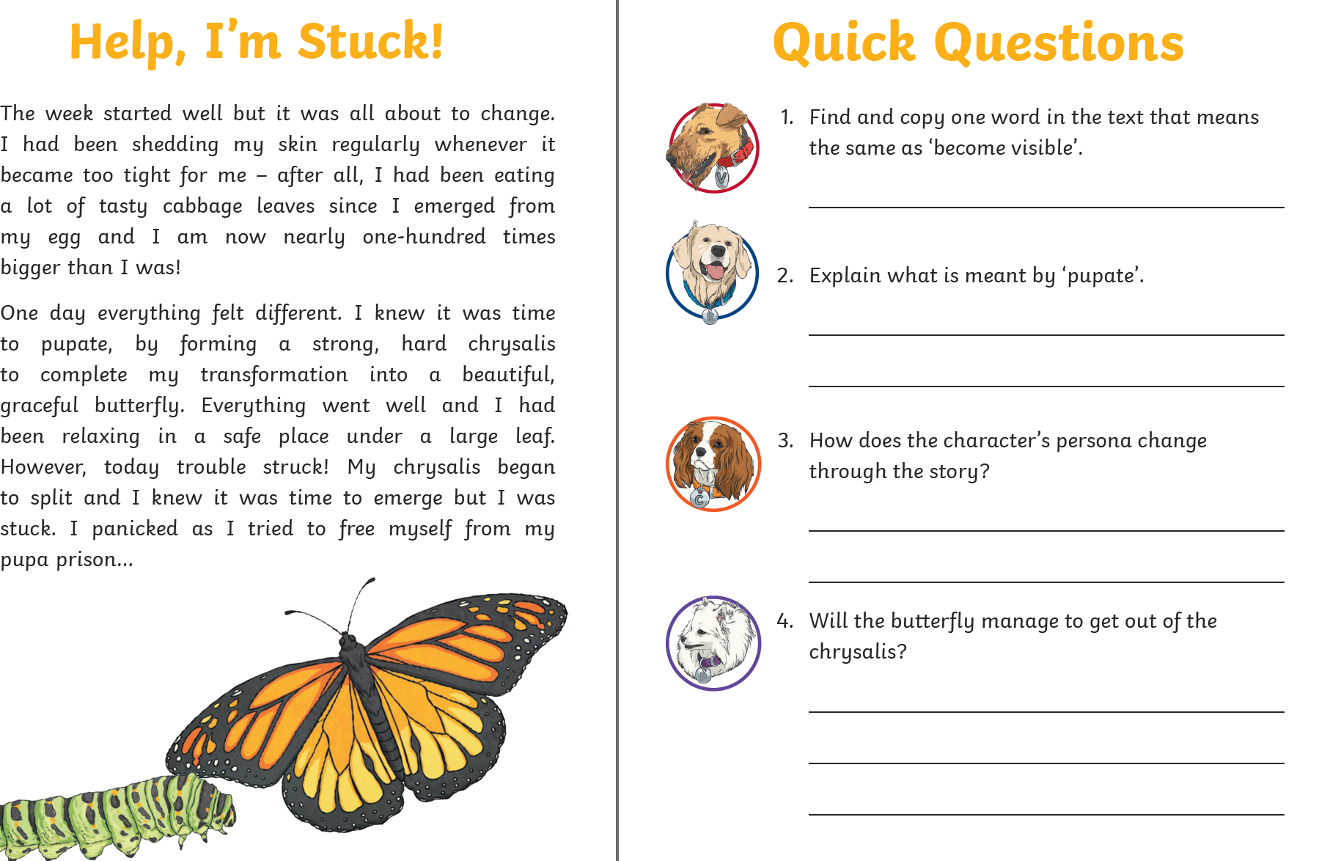

Grammar

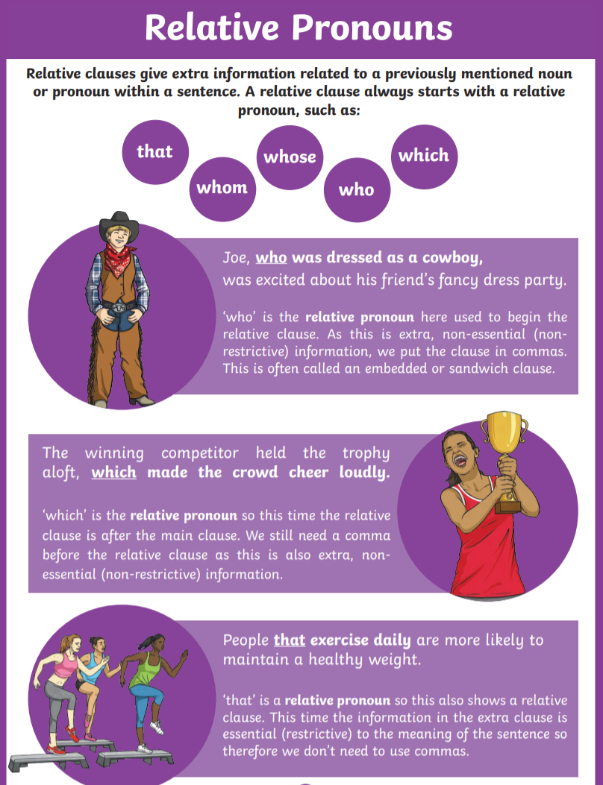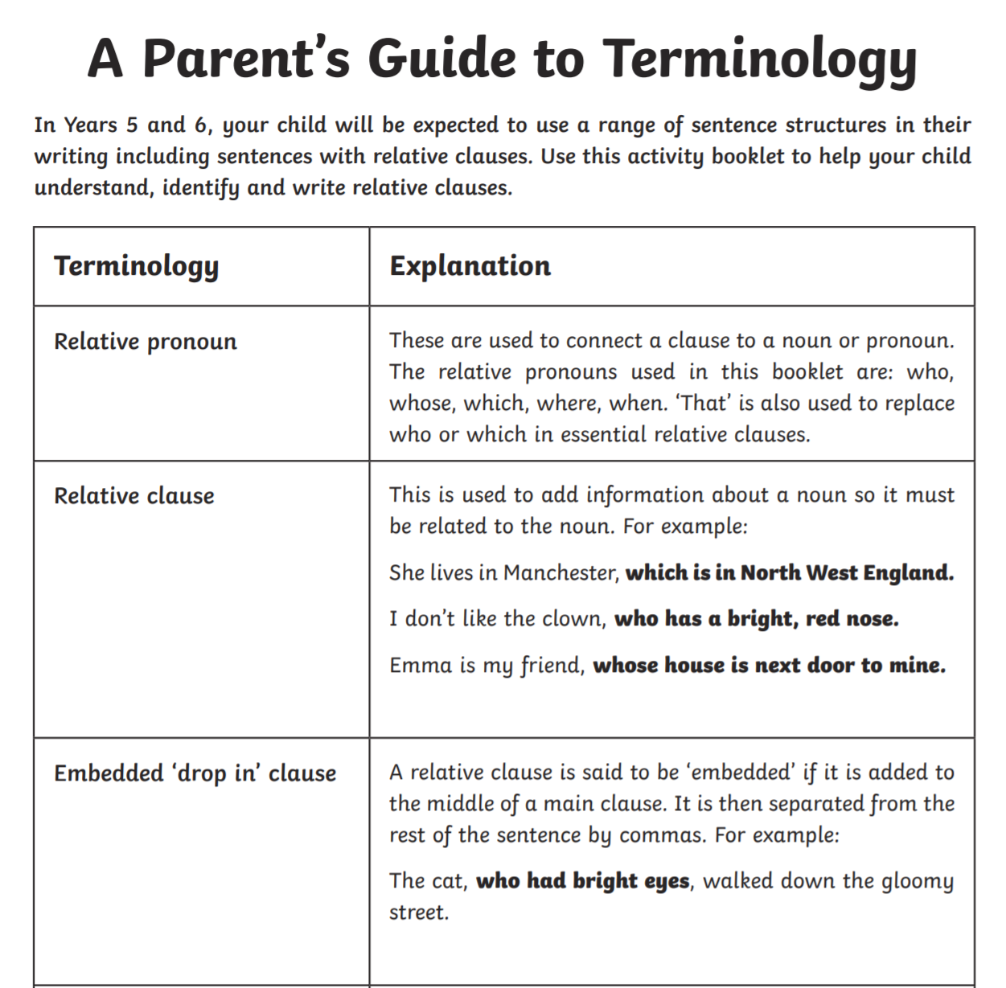

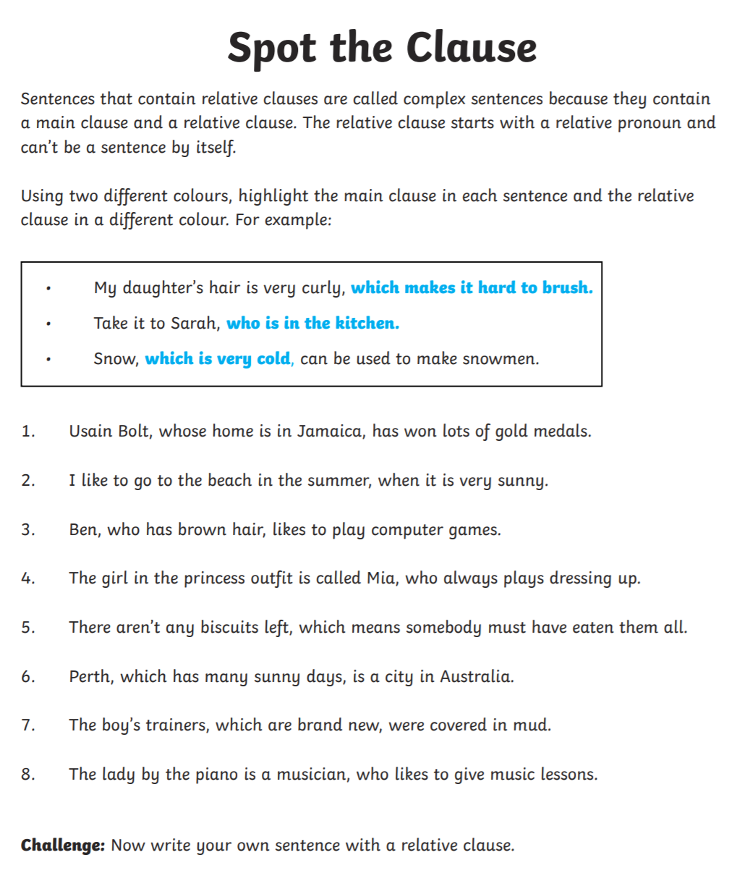

Writing

Choose one of the pictures below to write a character description. Try to include expanded noun phrases and a relative clause in your writing.




Spellings:
Mrs Wood’s group | Mrs Sloan and Mrs Valentine’s group | Mrs Wahl’s group
adorable  applicable  considerable  tolerable  desirable  believable  excitable  regrettable | address  busy  business  heart  fruit  breathe  strange  complete extreme forwards | any  live  mean  follow  place  very  sound  great  new  only

Try drawing around the shape spelling strategy

Draw around the words making a clear distinction in size where there are ascenders and descenders. Look carefully at the shape of the word and the letters in each box. Now try to write the word making sure that you get the same shape.



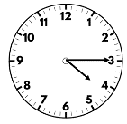
Maths:
Maths

What is the time on the clock?
Flashback 4!
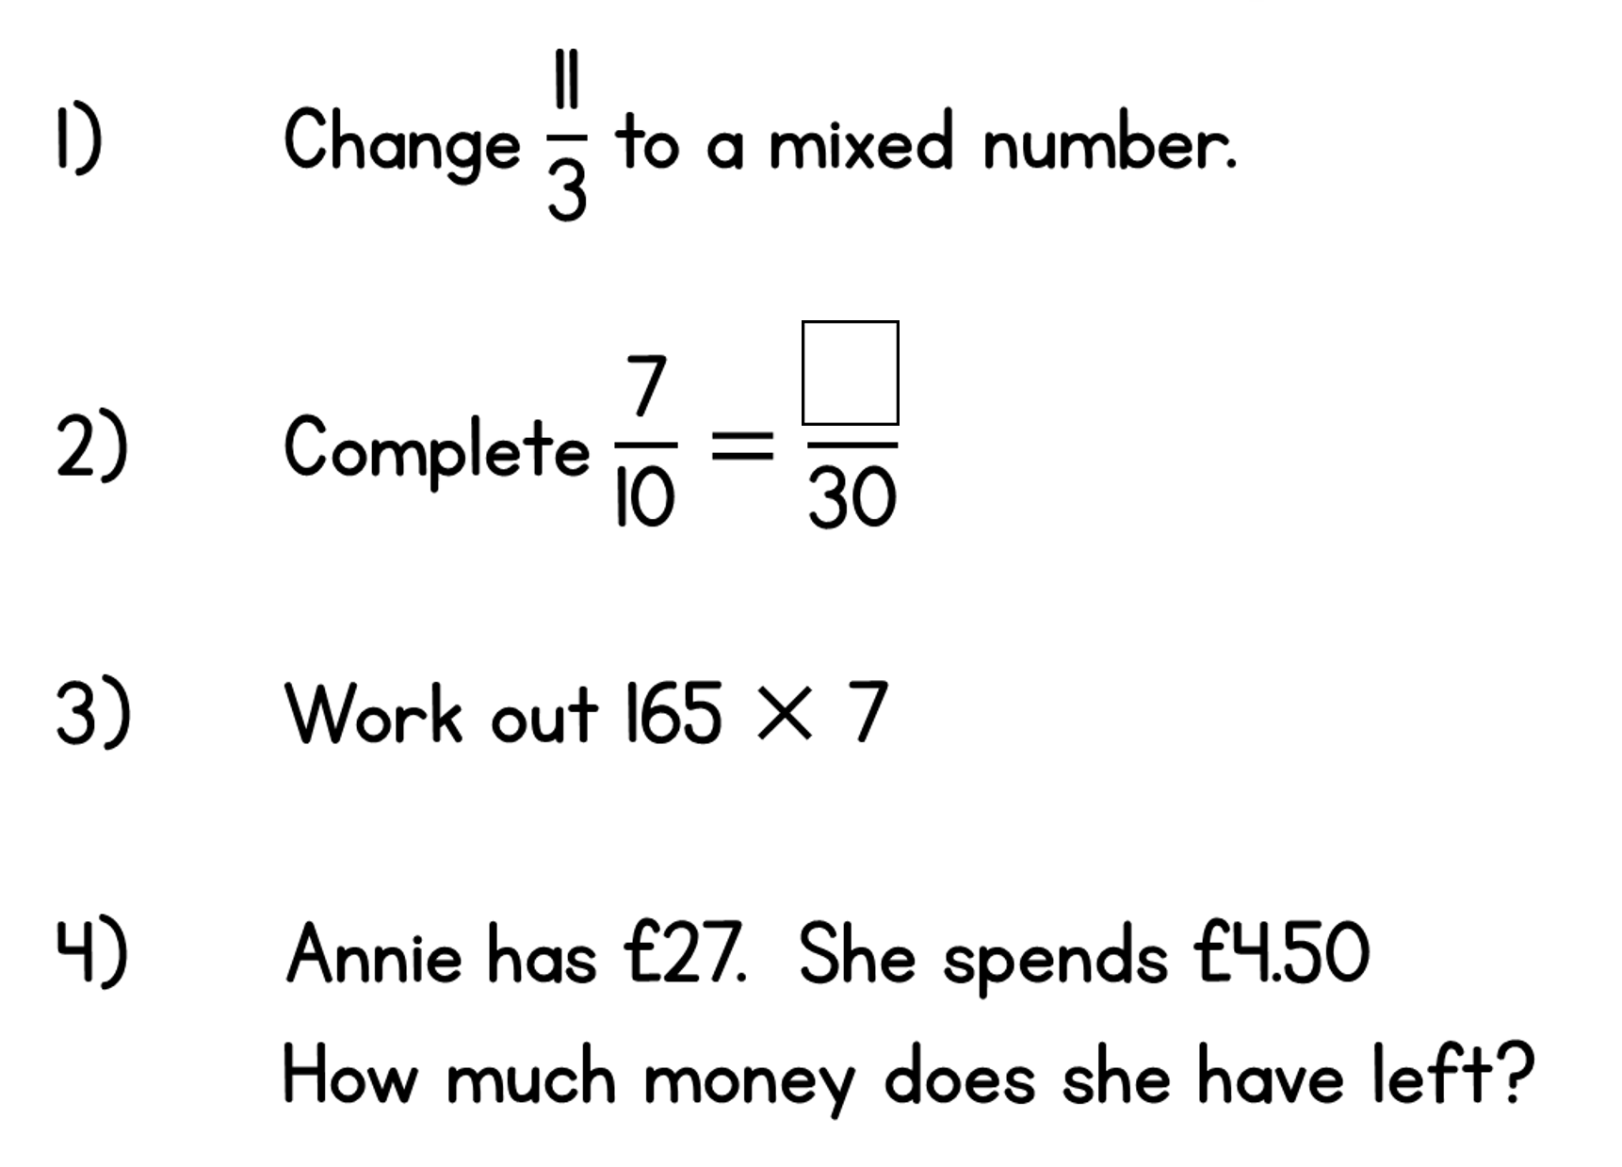

WRH Sumer Term Week 3 – Multiplication, Division and Perimeter
Look at the WRH website https://whiterosemaths.com/homelearning/year-5/ Summer Term week 3 for all of the lessons and questions on multiplication, division and perimeter. Each day you will find an easy to follow video tutorial with questions to work out. The children in year 5 have already done long multiplication and division, so this will be useful revision for them. Perimeter is a new topic that we have not done yet. You will notice that WRH are now only providing the free video tutorial on their website. WRH Worksheets and answers can now be found on the school website class page. Hard copies will be available from the school office alongside the home learning.
Additional practice questions can be found at the BBC Bitesize daily lesson website
https://www.bbc.co.uk/bitesize/dailylessons
When you have completed the lessons for the week, have a go at the 20 assessment questions on Professor Assessor. I will then be able to see how you are getting on.
Science:
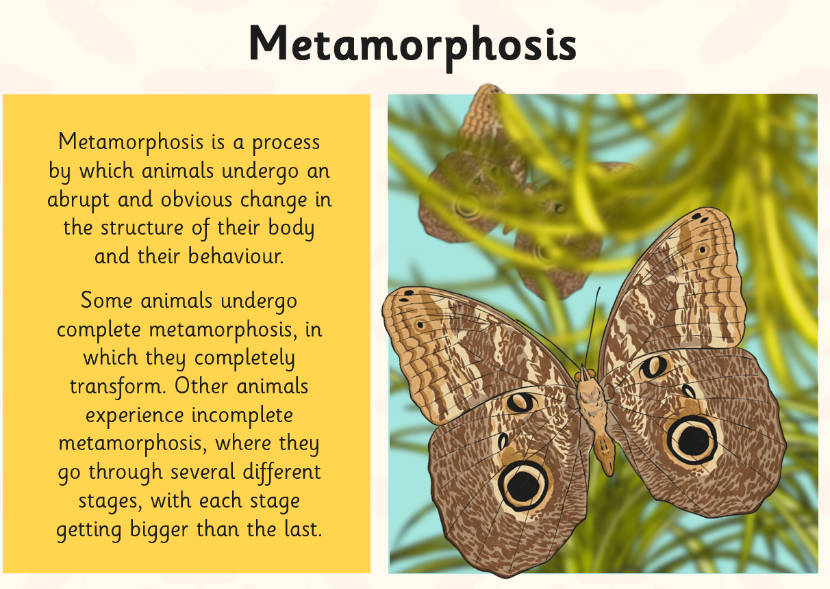
Metamorphosis

Do you know about any animals that undergo metamorphosis. How do they change and transform?
Choose an animal that goes through metamorphosis and find out about the different stages that it goes through.

Design a poster or Powerpoint to explain what you have found out.

History:
Mayan Gods and Religion
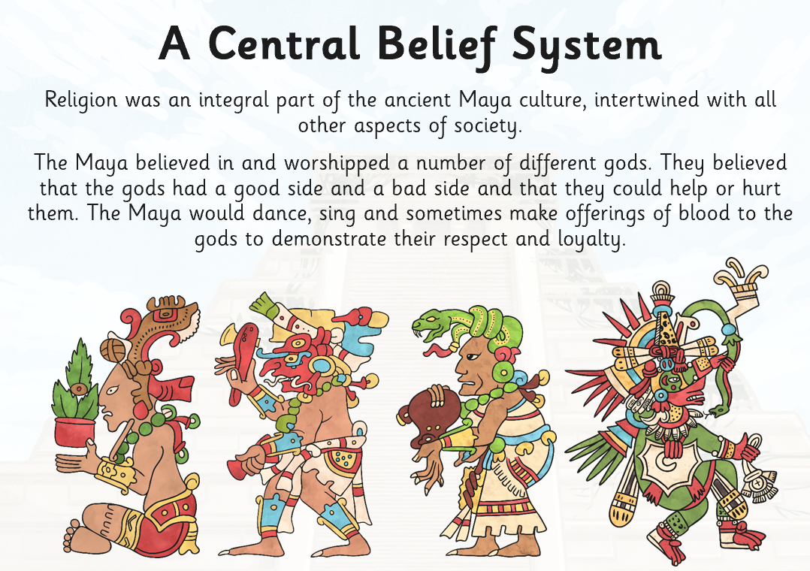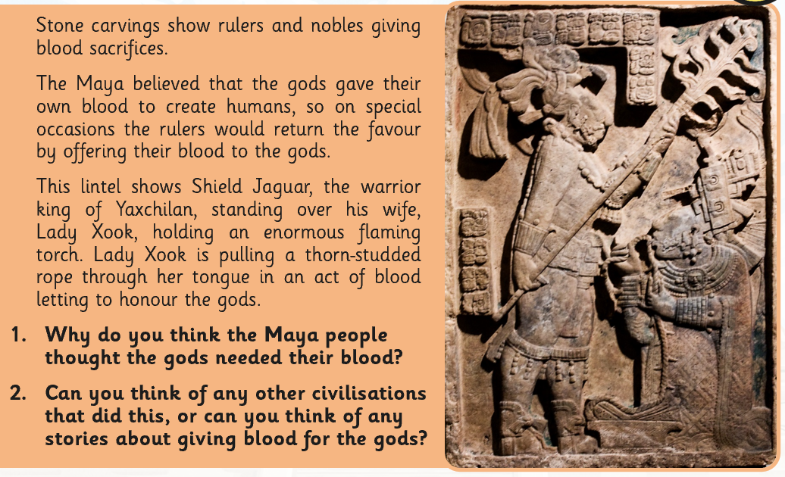
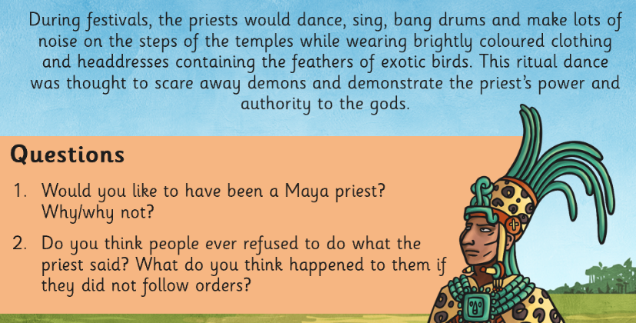
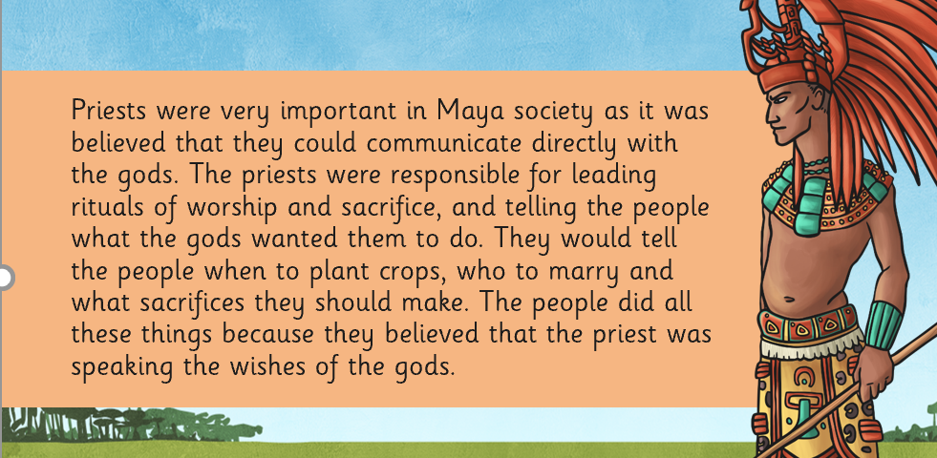

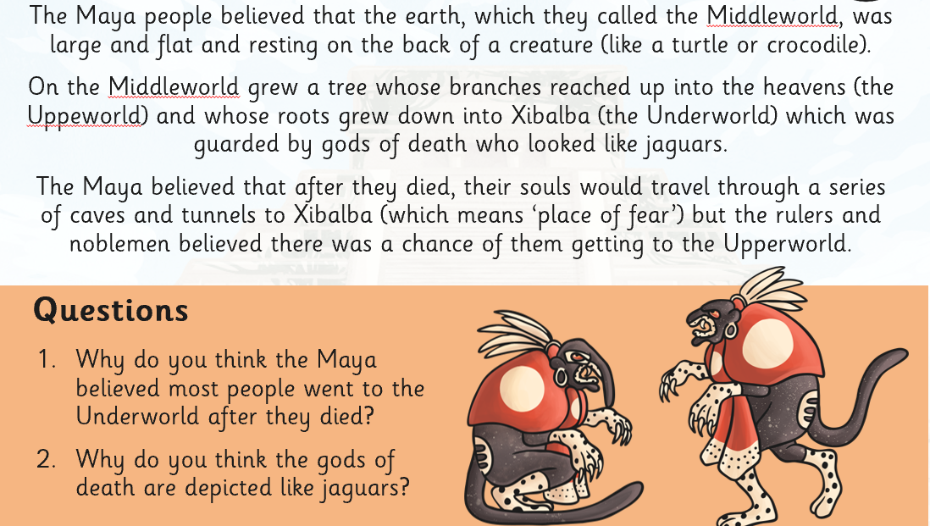

Challenge:
Can you find out about Mayan gods? Take notes on the god’s names and meaning, appearances and other facts/features so that you can write a Mayan God Fact File.


Geography:
Take a look at BBC bitesize daily lessons on Tuesday to find out all about different time zones.
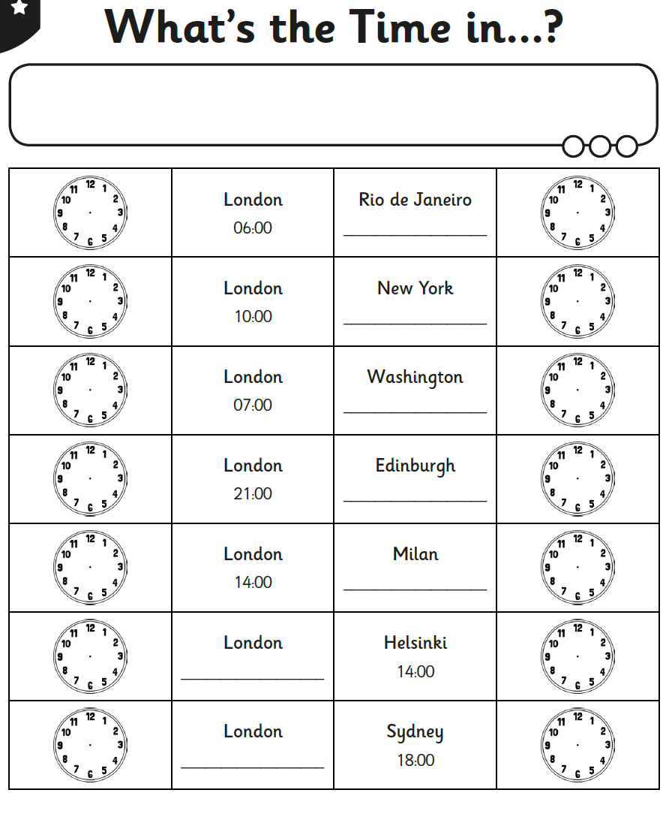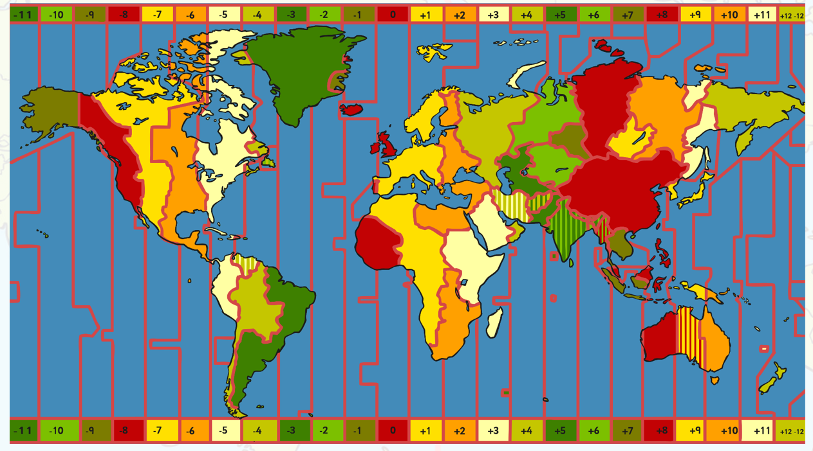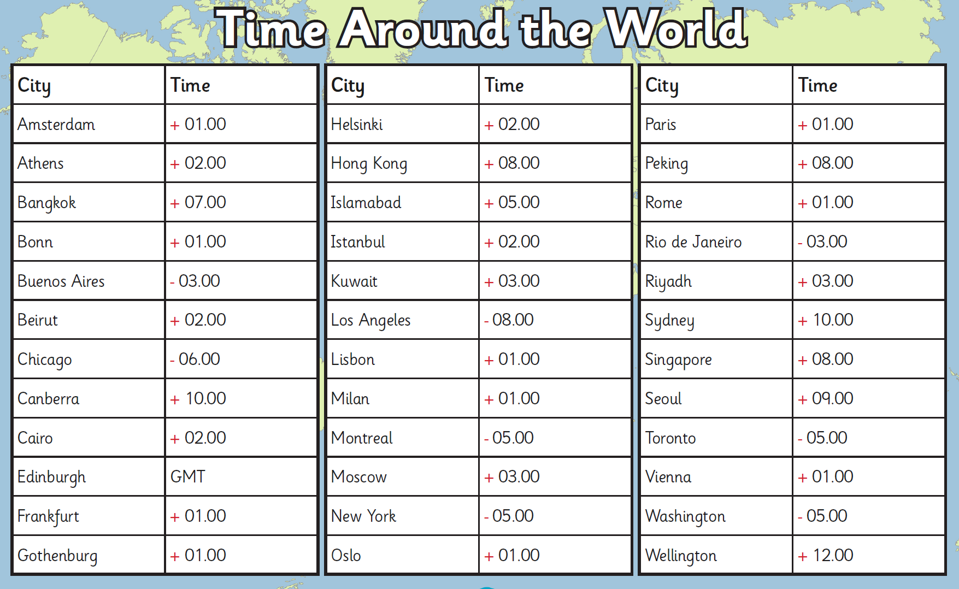

DT:
Have a go at designing and making your own draughts or chess set. You could then ask a member of your family to play with you. If you have a hard surface in your garden, you could draw a giant chequer board with chalks and make huge playing pieces. Perhaps you could use lego to make playing pieces. Other ideas could be making your playing pieces from modelling clay, recycled waste, fabric, buttons, coins or wood. I would love to see your creations so please send me a photograph if you choose to take up the DT challenge!
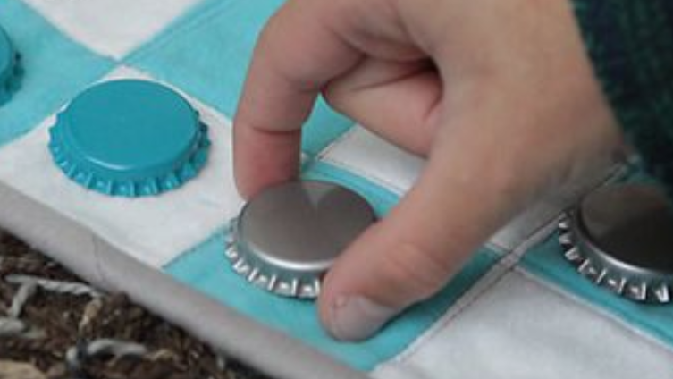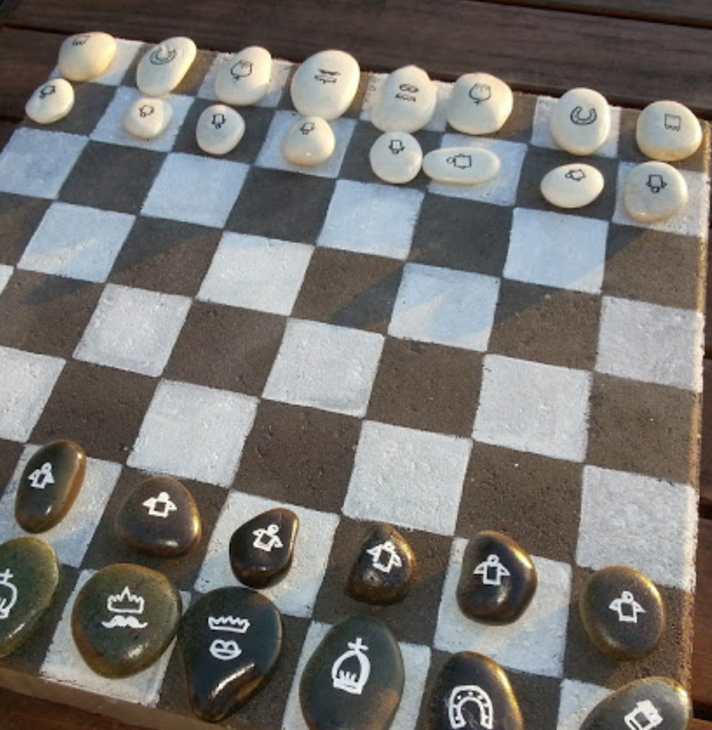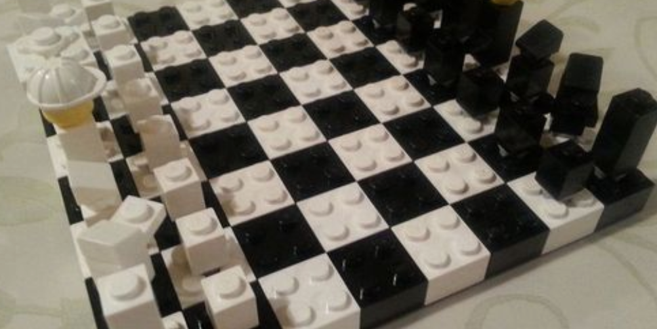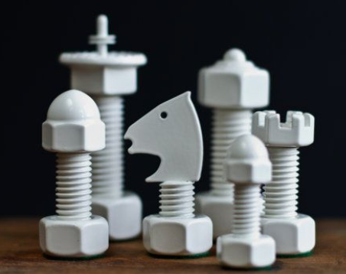

RE:
1. Take part in the latest competition run by Clifton Diocese. This fortnight, it is another writing task – this time linked to the theme of New Life. This can be as creative as you wish - a Sci-Fi about discovering new life in space, a birth, new life on a farm - anything that connects to the topic. Entries should be less than 750 words and sent to competition@cliftondiocese.com – Don’t forget to include your name and age. Alternatively, if you wanted to send your entries to the school, we would love to read them ourselves and celebrate them on a class pages. We can also submit them to the Diocese. The deadline is not until Friday 15th May, so you have plenty of time to start planning your ideas!

2. Choose a creative way to pray for / send positive messages to the country’s NHS and key workers who are helping to save lives and keep the country going. You could write/draw/paint on pebbles, make prayer flags to hang outside or stick a daily prayer on the fridge and say this each time you open it during the day! If you try any of these ideas, or have come up with your own inventive ways of spreading hope and optimism at home, then help us to share your prayers by sending in photos.
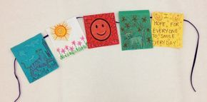
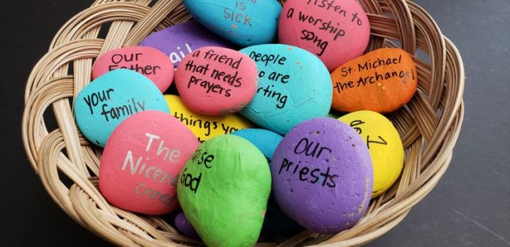
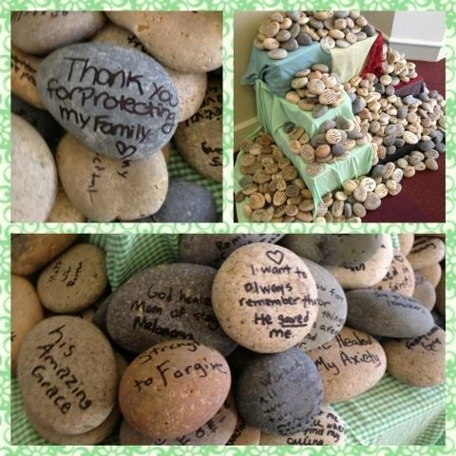

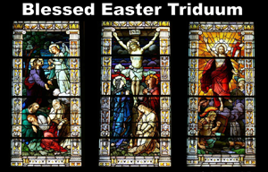
The Triduum

The Paschal Triduum reflects on the key elements of Jesus’ passion and resurrection, as told in the Gospels. It begins on the evening of Holy Thursday, reaches its most significant point during the Easter Vigil on Holy Saturday, and concludes on Easter Sunday.

Can you find out more about the liturgies on Holy Thursday, Good Friday and Holy Saturday, answering these questions?
- What is another name for Holy Thursday?
- What is remembered during the mass on Holy Thursday? Why?
- What does the priest traditionally do during this mass? What is the meaning of this?
- What is special about how the mass ‘ends’ on Holy Thursday?
- What is remembered during the service on Good Friday?
- The service on Good Friday is not a ‘mass’ as such. Can you explain why?
- How does the Vigil service on Holy Saturday begin? What is the symbolism of this?
- Many Christians are baptised following the mass, whilst others renew their baptismal promises. Why do you think this is?

Languages:
- Can you write down the numbers from 1 to 10 in Spanish? Are there any similarities or differences to the numbers 1 to 10 in French? Can you then teach someone in your home how to say these words?

Times Tables:
- Login to Professor Assessor to practise your times tables.

PE
- Visit The Body Coach TV YouTube channel each morning at 9am as he will be providing a live PE at home lesson.
https://www.youtube.com/channel/UCAxW1XT0iEJo0TYlRfn6rYQ

Mindfulness
- Need a time out? Go online to Cosmic Kids Yoga and follow a guided relaxation video @ https://www.youtube.com/user/CosmicKidsYoga

Useful Websites:
https://www.thenational.academy/- an enterprise set up by teachers and funded by the DfE which provides video lessons for pupils daily - from Reception to Year 10 - each lesson comes with a corresponding quiz and worksheet. Lessons last about an hour.
https://www.bbc.co.uk/bitesize/articles/z6vpnrd- building on their Bitesize website, there are daily lessons for every year group and every subject. There are also some guest star teachers such as David Attenborough and Jodie Whittaker.
https://www.prof123.co.uk/Children should have their login details
https://www.topmarks.co.uk/ - Maths and English interactive activities
https://www.youtube.com/user/GoNoodleGames - Physical activities
https://spellingframe.co.uk/ - Spelling Practice (There are free games – no signup needed)
https://mathsframe.co.uk/ - Maths Practice (There are free games – no signup needed)
https://www.nhs.uk/change4life/recipes - Cooking Ideas

