Home Learning
Year 6 – Term 5 Week 2
27th April 2020

Reading
This is a great opportunity to read some good books – if you don’t have your Green Record at home please keep a record of your reading in the back of your school exercise book.
Can you complete the tasks below during the week?
- Read at least a chapter a day. Ask questions about the book. Think carefully about questions that will help you to understand the text. (Allow about 15 minutes, not only at bedtime)
- Pick out any new words that you need to clarify (or select some of your choice). How can you find out what it means?
  - Read around the word – the paragraph, or sentences before and after it
  - Look for a root word
  - Try and exchange it with another word that would make sense
  - Look it up in a dictionary
  - Ask someone to help you
- Write a list of these new words and try to use them when talking or writing.
- Comprehension Task – please read the text and answer the questions using sentences in your notebook.
Who was Florence Nightingale?  Name: Florence Nightingale (named after the city in Italy where she was born)  Date of Birth: 12 May 1820  Family: Rich, upper class British family.  Occupation: In 1851 Florence became a nurse against her family’s wishes.  Work: Between 1854 and 1856 Florence took some other nurses to the Ottoman Empire to care for the wounded soldiers fighting in the Crimean War.  Known for: Establishing nursing as a respectable profession for women - in 1860 her nursing school opened. Whilst working hard to make hospitals more hygienic she wrote more than 200 pamphlets. | Known as: ‘The Lady with the Lamp’ because when she was checking patients during the night she held a lamp in her hand.  Comprehension Questions  - Why was Florence Nightingale named as such?  - Which word means the same as ‘regarded by people to be good’?  - Why do you think she wrote over 200 books or pamphlets?  - Why has the author used bold sub-headings?

English Writing
Biography Writing Checklist- I can:
Write an opening paragraph that introduces the person and explains why they are significant.
Explain key events of their life in chronological order.
Write in the 3rd person.
Link sentences using conjunctions.
Use a full range of punctuation - ,.?...():
Write a closing paragraph explaining why they will be remembered.

Biographical Writing. Can you recall any features of biographical writing? A biography is a text about a person’s life, written by someone else. It’s written in the third person (he,she) and is usually in the past tense. It discusses key achievements and details about their life.
This week use the information about Florence Nightingale or Carl Linnaeus to write a biography about them. Alternatively you could research your own person (they don’t need to be historical). Take two sessions. 1)Use the checklist to help plan your biography – think about content and design sentences using specific SPAG devices to show off your writing skills! 2) Write the biography, take time to edit in purple if possible. Read your work aloud as part of your check too.

Grammar
Word Classes Revision.
This is also a good opportunity to ensure you have completed Section 1 of your SPAG revision book.
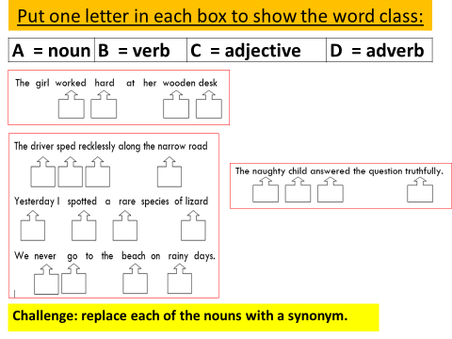
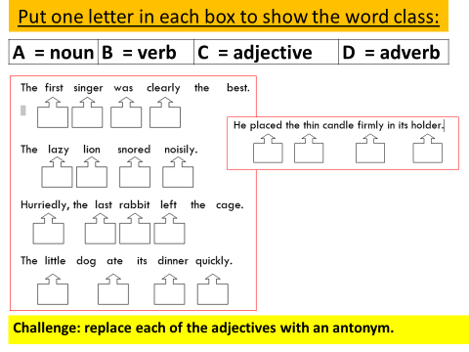

Spellings
Spellings
There are 10 spellings to learn each week. Use a dictionary or google to check the definitions of words you don’t know and use them in sentences. Could you find their synonyms and antonyms? What is the root word of each word? Use the look, say it, cover, write, check strategy to test yourself. -tious (ensure you know the meaning of each one)
ambitious
cautious
infectious
nutritious
pretentious
fictitious
superstitious
fractious
vexatious
anxious

Handwriting (Presentation)…please take a few minutes to go through your notebook so far. Use a straight side to underline all dates and titles. Ensure all proper nouns (days, months, names, places) have capitals please. Reflect..which are your neatest, most fluent words? What do you need to do next to make everything as clear?

Maths

Day 1- Four Number Operations

- 54352+45461=
- 47353+26318=
- 9176-1214=
- 4512-3612=
- 365x4=
- 531x45=
- 699/3=
- 416/8=
Day 1 Arithmetic:
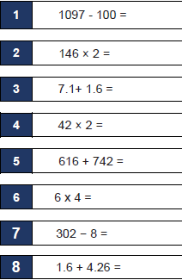
Day 1 investigation:
On the planet Vuv there are two sorts of creatures. The Zios have 3 legs and the Zepts have 7 legs. The great planetary explorer Nico, who first discovered the planet, saw a crowd of Zios and Zepts. He managed to see that there was more than one of each kind of creature before they saw him. Suddenly they all rolled over onto their backs and put their legs in the air. He counted 52 legs. How many Zios and how many Zepts were there? Do you think there are any different answers to this that would work?

Day 2- Four Number Operations
- 91765+ 11233=
- 43769+42726=
- 7501-2500=
- 5543-2711=
- 236x3=
- 543x33=
- 846/2=
- 144/4=

Day 2 Arithmetic:
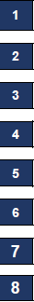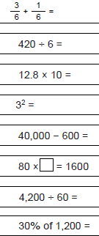
Day 2 Investigation:
If you cut a square diagonally from corner to corner you get four right-angled isosceles triangles.
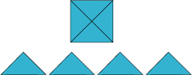

How many different shapes can you make by fitting the four triangles back together?
You may only fit long sides to long sides and short sides to short sides.
The whole length of the side must be joined.
You might like to record what you do.
Day 3- Four Number Operations
- 66411+ 23488=
- 482673+1234=
- 95952-23451=
- 19821- 14122=
- 653x7=
- 536x45=
- 848/4=
- 288/6=
Day 3 Arithmetic:
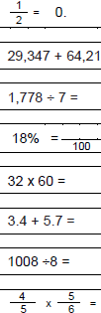

Day 3 Investigations:

Magic Vs
Place each of the numbers 1 to 5 in the V shape below so that the two arms of the V have the same total.
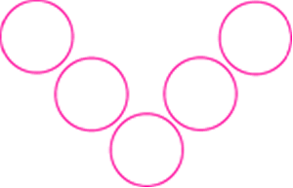
How many different possibilities are there?
What do you notice about all the solutions you find?
Can you explain what you see?
Can you convince someone that you have all the solutions?
What happens if we use the numbers from 2 to 6? From 12 to 16? From 37 to 41? From 103 to 107?
What can you discover about a V that has arms of length 4 using the numbers 1−7?
Day 4- Four Number Operations
- 11218+ 76521=
- 99922+14129=
- 777885-12132=
- 88761-649=
- 998x3=
- 337x56=
- 864/2=
- 234/9=

Day 4 Arithmetic:
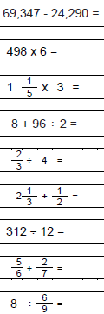
Day 4 Investigation:
A set of ten cards, each showing one of the digits from 0 to 9, is divided up between five envelopes so that there are two cards in each envelope. The sum of the cards inside it is written on each envelope:
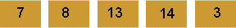
What numbers could be inside the 8 envelope?

Day 5- Four Number Operations
- 55328+ 21641=
- 1887+ 12221=
- 67671- 50471=
- 65111- 18330=
- 445x3=
- 543x13=
- 966/3=
- 144/3=
Day 5 Arithmetic:
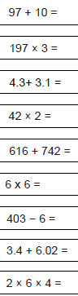
Day 5 Investigation:
What do you need to find a chosen number from this hundred square?
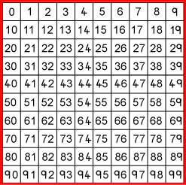
Four of the clues below are true but do nothing to help in finding the number.
Four of the clues are necessary for finding it. Here are eight clues to use:
- The number is greater than 9.
- The number is not a multiple of 10.
- The number is a multiple of 7.
- The number is odd.
- The number is not a multiple of 11.
- The number is less than 200.
- Its ones digit is larger than its tens digit.
- Its tens digit is odd

What is the number?
Can you sort out the four clues that help and the four clues that do not help in finding it?

Religion
Could you make an Easter Garden? Think about the story of Easter and what natural materials you could use to represent these. Below are some ideas. Please do send us any pictures of your creation!
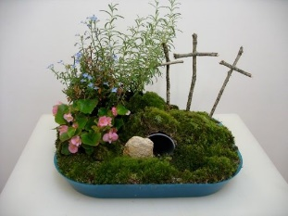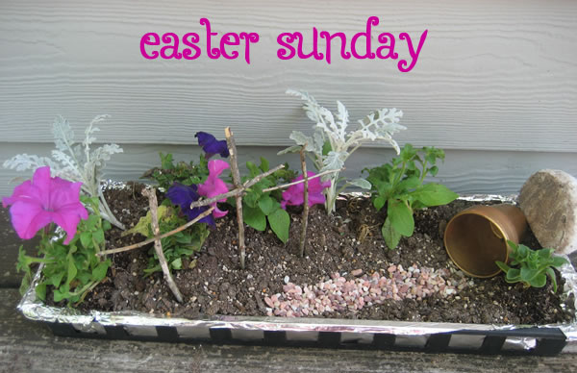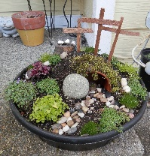

Discuss this question: Why is the Easter story relevant today?
Could you write a paragraph explaining your response to this?

Science
Watch this clip to find out about classification and the work of Carl Linnaeus.
https://www.bbc.co.uk/teach/class-clips-video/science-ks2-the-work-of-carl-linnaeus/zhnjf4j
- Make notes – jot down any vocabulary or ideas that you think are useful.
- Write a definition of the following: amphibian, taxonomy, mammals
- Using your list of species from last week (or make another) please classify them.
- If you can’t watch the clip please read the information below and use a dictionary to help you.

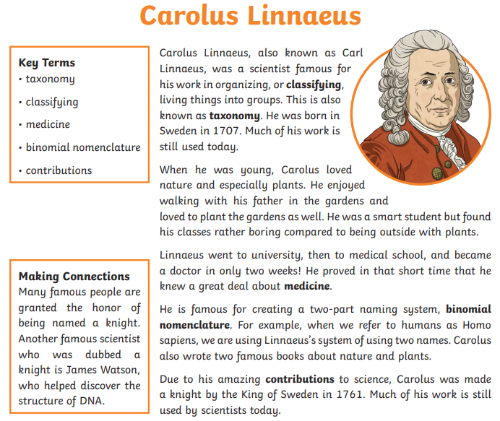

History

https://www.bbc.co.uk/bitesize/topics/zq6svcw/articles/zg2htv4
Using the above website, consider how children’s lives differed in the Mayan civilisation to our own. Split a piece of paper in two and on one side draw key features from the Maya’s life and on the other, key features from yours today. (e.g: You might draw what they would wear, then what you would wear)

Art

We have the Mayans to thank for giving us chocolate. Archaeologists believe that chocolate, or Xocolatl, as the Mayans called it, was cultivated as early as 900 AD in Mesoamerica. The Mayans, and later the Aztecs, made a beverage from the beans of the cocoa pods that was used for a popular, everyday drink but also used in rituals and healing practices.

Ask your parents if they can spare a tea bag, some cocoa or coffee powder. Mix with a little water to create your own set of paints in a shade of brown. (Or look through your pens and pencils to find items of the same colour but different shades)
Have a go at painting your own scene:

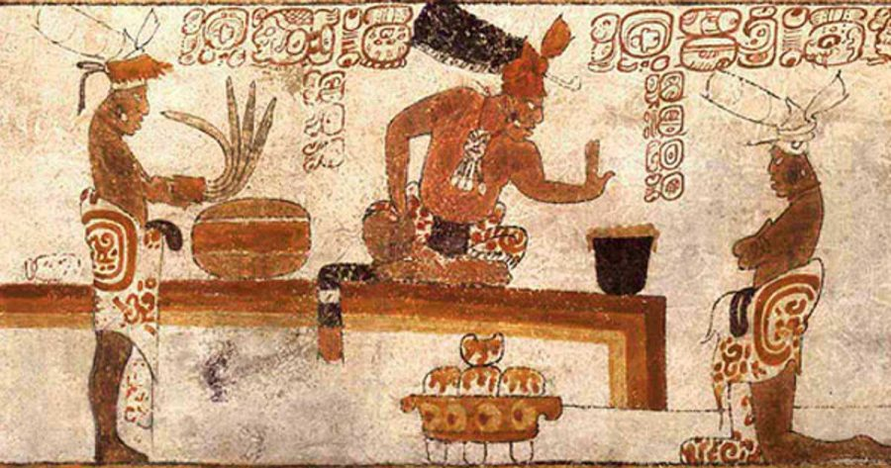
Ancient Mayans Traded using chocolate.

Useful Websites:
https://www.nhs.uk/change4life/recipes - Cooking Ideas
professor assessor
https://www.natgeokids.com/uk/ - for inspiring information about our planet.

https://www.bbc.co.uk/bitesize -lots of ideas and information.

