Home Learning
Reception – Term 5
Week 4 – Monday 11th May 2020

Below you will find activities for all of the 7 areas of the Early Years Foundations Stage curriculum and an activity for Religious Education (RE). Please pick what works for you and your child.

1: Literacy
Phonics & Writing (few options)

- Tune into the DFE Daily phonics lesson on YouTube (delivered by the English Hub).

- Use ‘Mr Thorne does phonics with Geraldine’ on YouTube. Concentrate on one or two sounds a day in your work book after watching the video.

- Use a Phonics app such as ‘Teach your monster to read’, ‘BBC BITESIZE’ (https://www.bbc.co.uk/bitesize/topics/zvq9bdm) or ‘Phonicsplay.com’.

- Or use Oak National Academy. You will find a sequence of lessons for the ‘Three Little Pigs (week 1), ‘Goldilocks and the three bears (week 2) or ‘Little Red Riding Hood. Phonics will be incorporated into these English lessons. I can’t wait to see and hear your stories at the end of the week. Maybe, your parents could film you reading your story and you could email it to me.

- The best thing that you can do to support your child’s phonic journey is get them to write a simple sentence every day. By doing this simple task they will be practising so many skills, such as: creating a sentence structure, segmenting words, blending words, developing pencil control and remembering finger spaces and possibly full stops.

- Your child could write a fact file about different animals (pick an animal a day) and make a massive book. They may be interested in a science or history topic that they could write about.

- Practise reading your tricky words (below), using the letter names to read them through sight. Then say and record them as a sentence. For example 'some', I like to eat some chicken for my lunch.
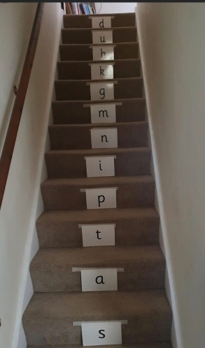
- After making your own lunch or baking, write a list of instructions on how you made it. Challenge: Use time connectives such as first, next, then, finally.

- Read your favourite story book with your adult, using your phonics. After, write a book review. You can use the sentence starters ‘I liked…, I give it ___ stars’

- You could try the stair challenge with either phase 3 sounds or key words. What game can you think of with a parent?
Reading
- Pick a new eBook for the week (‘Big Cat’ or ‘Oxford Owls’ have free eBooks) or you could trade your 3 school books in for 3 new ones at school (please email the school office to arrange this before turning up at school). Please remember that we have been developing the children’s fluency in Reception so please reread the same book throughout the week.
2: Maths (few options)
Number

- Pick a sequence of lessons from Oak National Academy –
Week 3 – ‘’Calendar and Time’’ or Week 4 – ‘’Numbers within 20’’
https://www.thenational.academy/online-classroom/reception/#schedule

- Play a Maths game on Top Marks.
https://www.topmarks.co.uk/maths-games/3-5-years/counting

- No screen needed: (Numbers 1-20) - Find as many paired items in your house as you can and count them in 2's to find the total. These can be shoes, socks, gloves, etc.
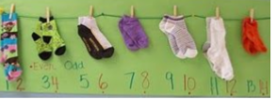
- Make handprints, cut them out, number them (5,10,15) and learn to count in 5s. Can you order them? How high can you go?

- Measurement: While in the bath or shower explore capacity by filling different containers and describe them using capacity language such as 'full', 'nearly full', 'half full', 'nearly empty' and 'empty'.
- Space: Hide an item with your family and give them instructions on how to find the item using positional language such as 'over', 'under', 'next to' and 'in front of'. For example it is next to a table.
3: Communication and Language
- Use your toys at home to put on a puppet show for your family. Use our story language of 'Once upon a time', 'Unfortunately' and 'Luckily'. You could even create tickets and posters to advertise your show!
- Play a game of I-Spy with your family using your phonics. 'I spy with my little eye, something beginning with...'
- Act out your favourite story with your family.
- Learn a favourite poem.
4: Personal Social and Emotional Development
- Create a memory jar, writing down all of your wonderful memories you have made with your family while you have been at home. You can use sentence starters such as 'I liked...' or 'I remember...'.
- Create a kindness calendar, recording 1 kind or helpful thing you have done each day.
5: Physical Development
- Can you help your family to make your own lunch? This could be buttering bread for a sandwich, working with your adult to cut fresh fruit or vegetables or helping to mix and stir some delicious food.
- Learn how to tie your shoelaces to show your Diamond Power (independence skills).
- Practise drawing and cutting around different 2D shapes that you can spot in your house.
- See the Ball Skills sheet (below).

6: Understanding the World
- Build a den using different items from your house. How can you make it light or dark inside? What will you use to join it together?
- Make phone call to celebrate a special occasion; a birthday, VE day, etc, or to someone who is also at home. Can you dial the numbers to your chosen person?
- Oak Academy – Foundation Subjects – Week 3 – People Who Help Us (5 sessions)
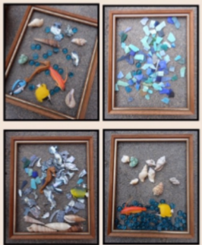
7: Expressive Arts and Design
- Make a card to brighten a family or friend’s day, this could be for a special occasion such as a birthday or for someone you haven't seen in a while to make them smile.
- Practice singing different songs with your family. These could be nursery rhymes, songs from your culture or you and your adult could share your favourite song with each other.
- Use small resources from around your home to make a picture; you could use buttons, screws, pebbles, beads or pom-poms. What could you use to make sunshine?

8: Religious Education

- Create a Cross or your own prayer symbol for you to use during prayer time.
