Home Learning
Year 3 – Term 6 Week 3
22nd June 2020

Hello Children and Parents,
I hope you have enjoyed your geography focus week on Rainforests. Thank you for your rain forest project work that has been sent in. I loved your save the rainforest posters too. It is important to learn about our precious world so we can look after it.
Many of you also sent in fantastic work from the Jungles English Talk for writing pack. Well done! They were wonderfully imaginative jungles you wrote about.
Hopefully, you are now a bit better on telling the time. Keep checking your watch!
This week is an art and design/ technology focus on rainforests so you can learn how to draw animals and even make your own bean bag frog!
Maths is all about shape and space this week so I hope you enjoy that too.
English is another pack from talk for writing called The Stone Trolls (some of you may be finishing off the last one so don’t worry as we all write different amounts at different speeds).

Exciting news: Check out Mrs Clermont’s crafty corner and Recipe Corner ideas in this pack

All best wishes,

Miss Wilkinson and the Year 3 team

Maths Topic: Shape and Space
Please work through the plan bee lessons 1-5, (on the classpage). Each lesson has a plan (for parents if needed). There is a powerpoint presentation to work through for each lesson followed by the worksheets. (A is basic skills, B is middle and C is the challenge advanced work). Only print off sheet A or B or C depending on ability in this area.
Lesson – Learn to read coordinates – Read the letter first (along the corridor) then up the stairs – read the number.
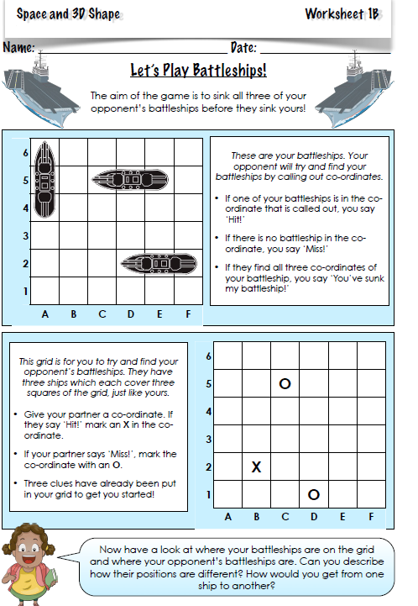
Lesson 2 Learning Objective:
To be able to use the four compass directions to describe movement about a grid

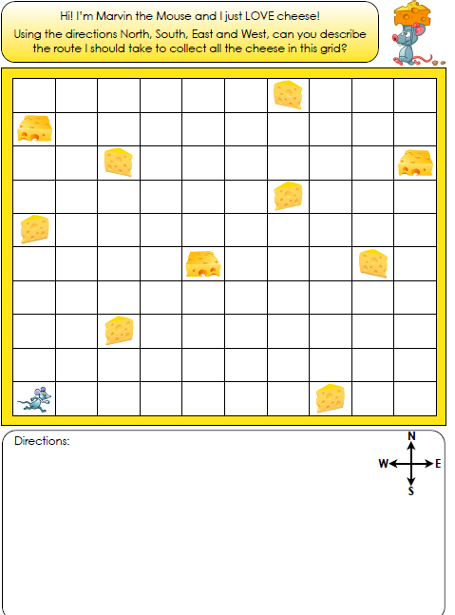

Lesson 3 Learning Objective:
To be able to identify and describe 3D shapes and their properties. Can you identify the number of faces, edges and vertices each shape has. Vertices are poity parts.
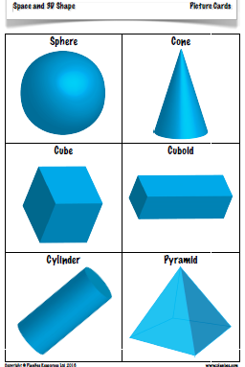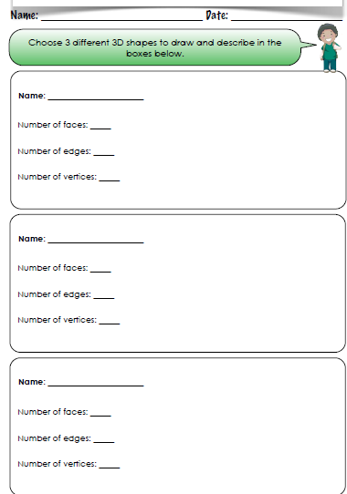

Lesson 4 Learning Objective – To identify shapes in everyday life
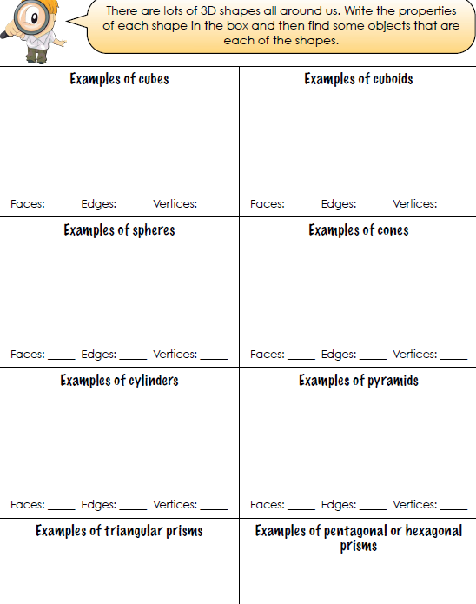
Lesson 5 Learning objective: To make 3 D shapes from nets
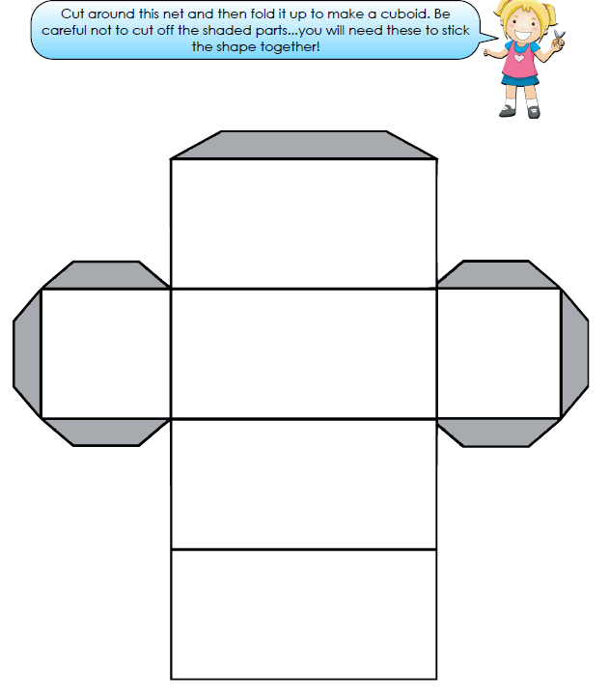
English: Please download this from the class webpage (included in printed pack only)
https://www.talk4writing.com/wp-content/uploads/2020/04/Y3-Dean-Stone-Trolls.pdf
Work through the learning at your own pace. 2 pages + per day. However, the longer writing activities will take 2 to 3 lessons. You may want to take the pack over 2 weeks.

Art – Learning to draw Drawing Rainforest Animals
Please follow the Plan bee unit on rain forests art on class page. It is brilliant and will teach you how to draw lots of plants and animals. There is a powerpoint and worksheets for each lesson plus a FSD (a ‘fancy something different’ activity too) There are 5 lessons for this topic as we focus on geography this week.
Lesson 1 Learn to draw a range of rain forest animals
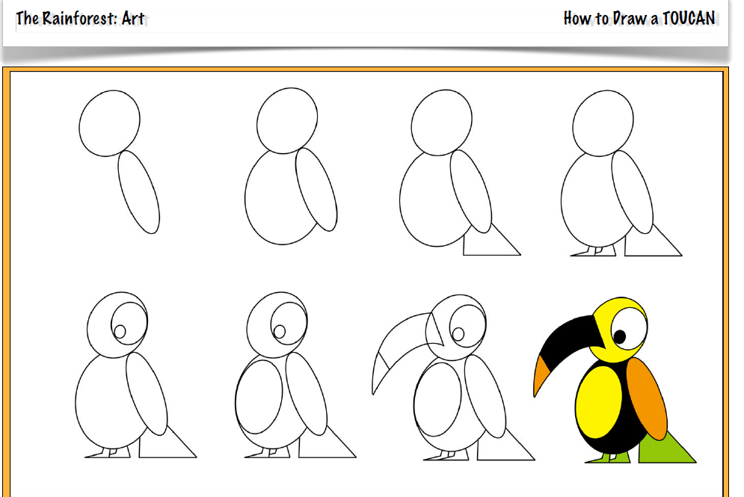
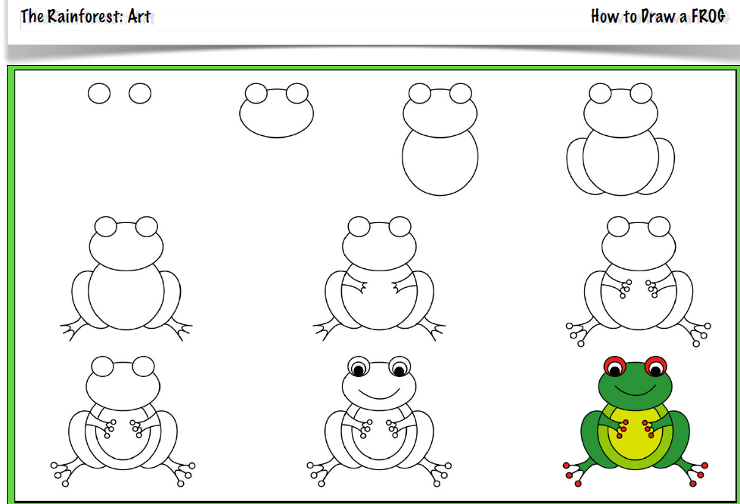
Lesson 2: Learn about the Artist Henri Rousseau – he painted pictures of jungles but had never visited one! Look closely at the colours he uses. What do you notice about the trees and leaves? Are they true to real life? Can you paint a picture in the same style or use your own style? 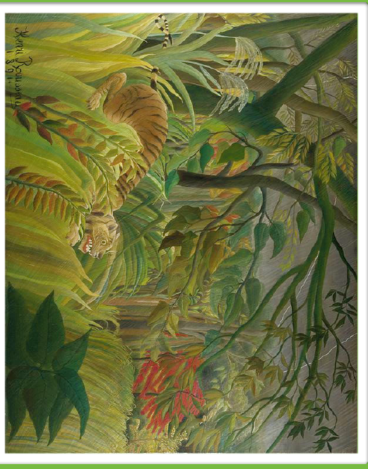

Lesson 3: Design and make your own animal mask using what materials you have – you can use cereal packages for your base.
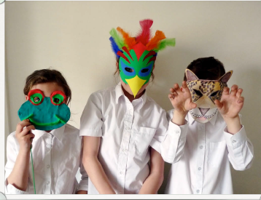
Lesson 4 and 5 : Design and Technology – Design and Make your own Rainforest frog bean bag
Please follow the Plan bee unit on rain forests art on class page. There is a powerpoint and worksheets for each lesson plus a FSD (a ‘fancy something different’ activity too) There are 5 lessons for this topic as we focus on geography this week
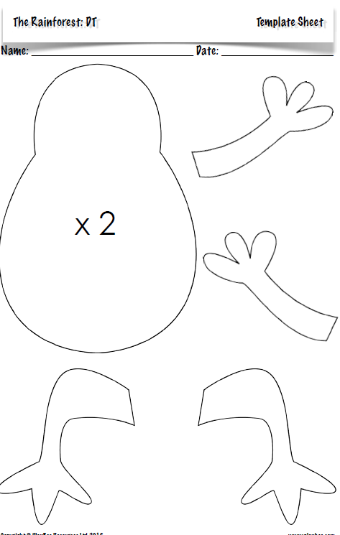

PE

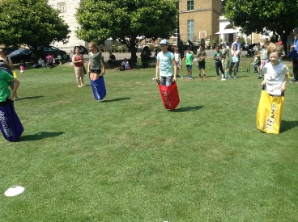

Outdoor P.E:
Prepare for your own made up sports day. Practise egg and spoon races, sack race, sprint, hurdles, even space hopper races. Can you make up an aiming game or a game using equipment you have in your garden? Please send your pictures of your practise to Miss W. Time yourself and see if you can improve on it through the week. Remember to stretch and warm up beforehand and cool down stretches afterwards. Keep drinking plenty of water to keep you hydrated.

R.E Year 3 and 4
Calling
Read the story of Samuel below. You can also watch a song on YouTube which summarises the story nicely. https://www.youtube.com/watch?v=SyouqyzeBhE
Once you have read the story, have a go at answering the following questions:
1. Why do you think Samuel didn’t recognise the voice of God?
2. Why did Eli recognise eventually that God was calling Samuel?
3. What did Eli tell Samuel to say? Why do you think these words are important?
4. What changes will it make to Samuel if he really listens to God?
5. Do you think God still calls people to follow him today? If so how?
Create a poster called ‘Speak Lord your servant is listening’, showing your understanding of the story.

The Call of Samuel
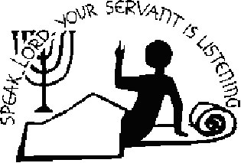
After Samuel’s mother had been married some years she still had no children so she prayed to God for a child and she promised that her first born child would serve God. Samuel was her first born. When Samuel was old enough she took him to the temple to be a servant to Eli who was an elderly Jewish priest. (It wasn’t like today - children did all kinds of work then and by going to the temple Samuel would also have got an education)

One night Eli, whose eyes were becoming so weak that he could barely see, was lying down in his usual place. Samuel was asleep in his own place but near enough so that if Eli called for him he would hear. Then the LORD called Samuel.
Samuel answered, “Here I am.” And thinking it was Eli he ran to Eli and said, “Here I am; you called me.”
But Eli said, “I did not call; go back and lie down.” So he went and lay down.
Again the LORD called, “Samuel!” And Samuel got up and went to Eli and said, “Here I am; you called me.”
“My son,” Eli said, “I did not call; go back and lie down.”
Now Samuel did not yet know the LORD: The word of the LORD had not yet been revealed to him.
The LORD called Samuel a third time, and Samuel got up and went to Eli and said, “Here I am; you called me.” Then Eli realized that the LORD was calling the boy. So Eli told Samuel, “Go and lie down, and if he calls you, say, Then Samuel said, “Speak, for your servant is listening.”
So when Samuel heard the voice again he said ‘Speak Lord your servant is listening.

Mrs Clermont’s Crafty Corner
Pebble Pets
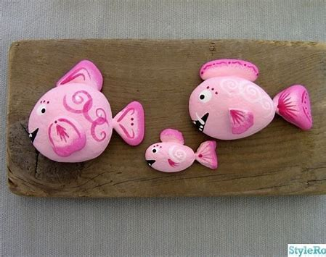
You’ll need:
Large pebbles, coloured paints (acrylic paints are best if you have them), paint brushes, googly eye’s if you have them or black and white paint if you don’t

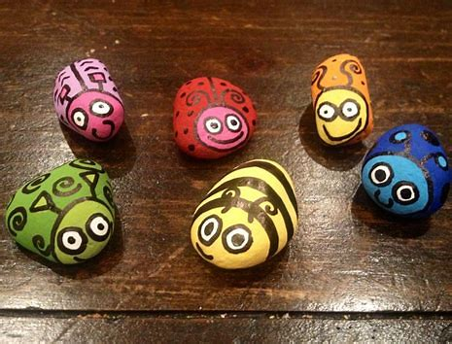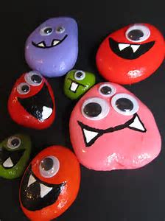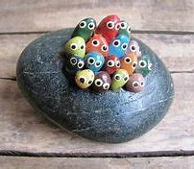

Choose what you’d like to paint…. A lady bird, a bee, a mouse, it doesn’t need to be an animal, it could be an insect, a bug, an alien.
Remember to let layers of paint dry before you add detail on top and keep one brush per colour or wash it in between. You can add wool, cotton balls or glitter…… have fun!!
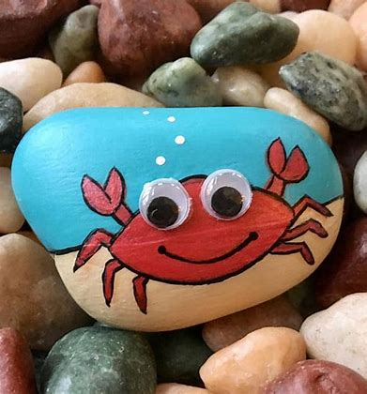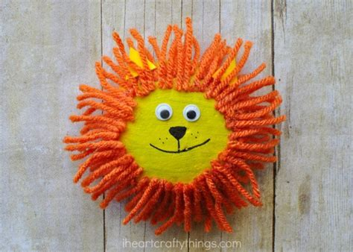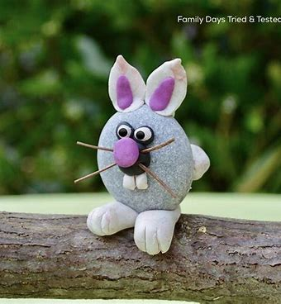

Mrs Clermont’s Recipe Corner

Soft Bake Double Chocolate Cookies

Ingredients:
150g Butter / Margarine, 170g Brown sugar, 50g White sugar, 1 Egg, 1 ½ teaspoon Vanilla,
125g Plain flour, 150g Cocoa, ½ teaspoon Baking powder, ¼ teaspoon Salt,
200g Chocolate Chips (white or dark chocolate)

Mix together the sugars and butter until creamy in texture and lighter in colour
Add egg and vanilla and mix in well until completely combined
Add flour, cocoa, baking powder and salt and mix well
Add chocolate chips and mix well
Divide into 50g balls, flatten slightly and space out on a lined baking tray, this will make around 14 cookies.
Bake for 10 – 15 minutes at 160⁰centigrade
When baked they should still be slightly soft in the middle

