Home Learning
Year 5 – Summer Term 6 Week 4 - ANSWERS
22nd June 2020

Reading Comprehension

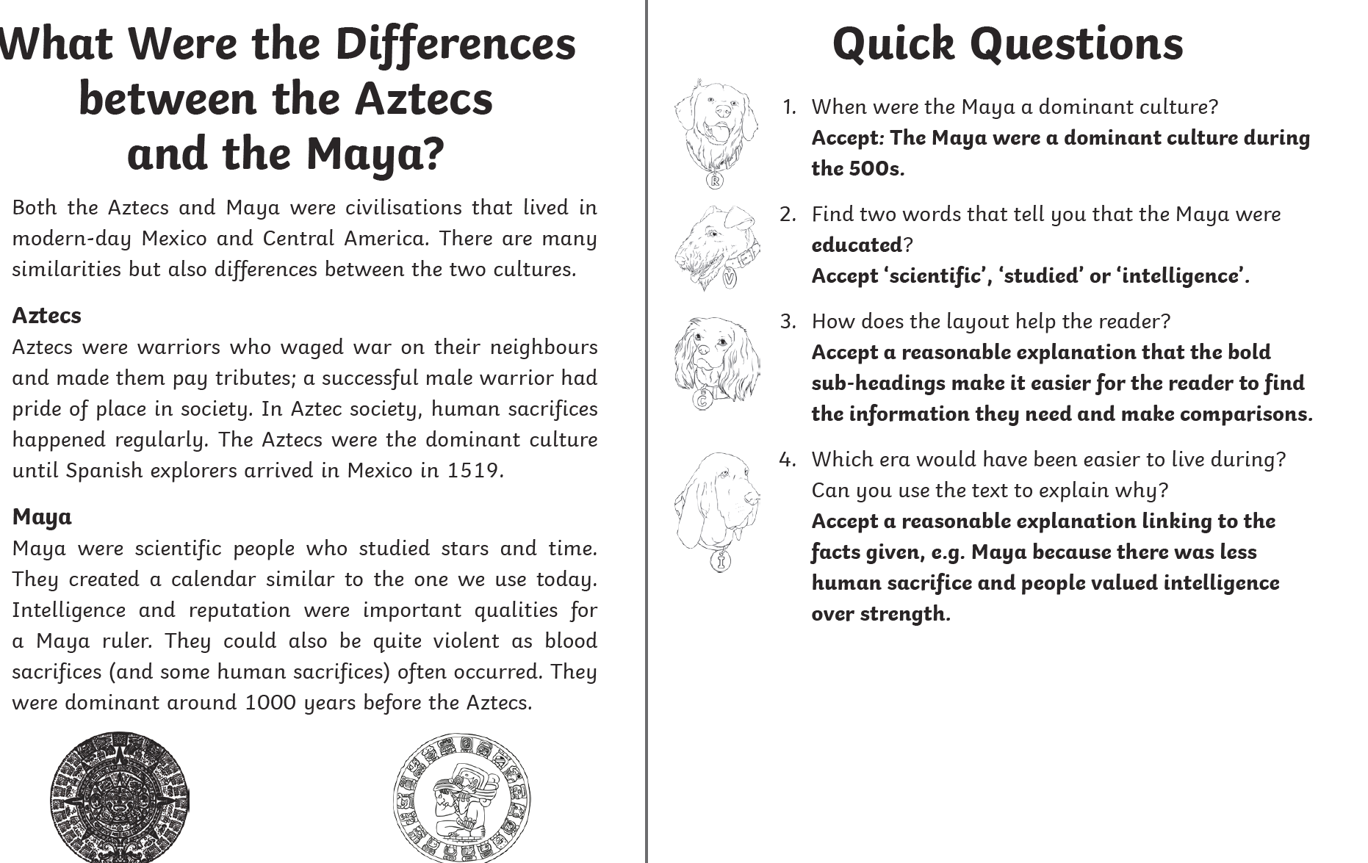

Maths:

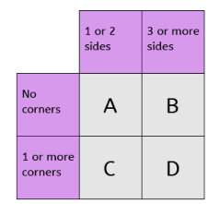
Flashback 4!
This carroll diagram is used for sorting shapes. Which box would you put a circle in? A
Maths

- £32.06 + £27.19 = £59.25

- 45200 ÷ 10 = 4520

- 9 x 7 = 63

- ⅜ of 64 = 24

