Home Learning
Year 5 – Summer Term 6 Week 3
15 th June 2020

English

Reading Comprehension

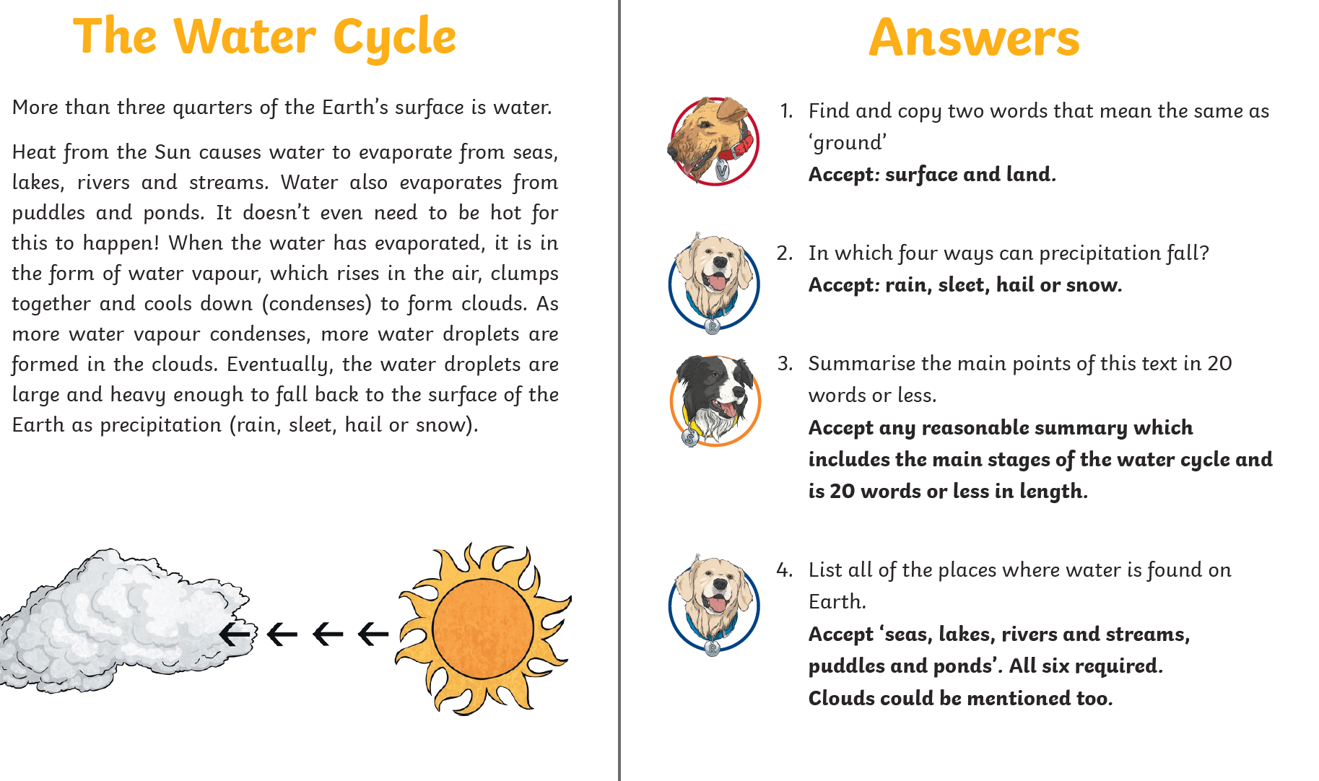

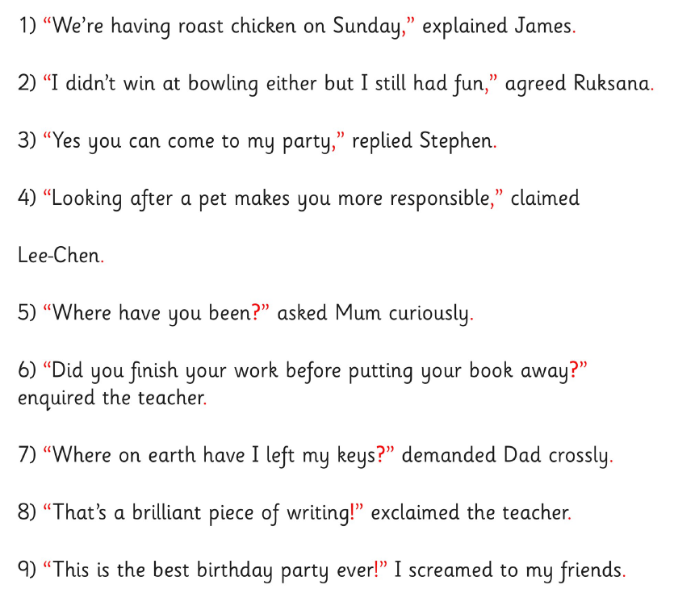

Maths

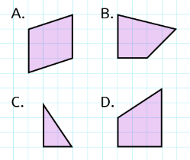
Flashback 4!
Maths

Which shape has no right angles? A
- 1 – 0.6 = 0.4

- 362 x 1000 = 362000

- £46 + £32.50 + £0.62 = £79.12

- ⅛ of 240 = 30

