Home Learning
Year 5 – Summer Term 6 Week 2
8th June 2020

English

Reading Comprehension

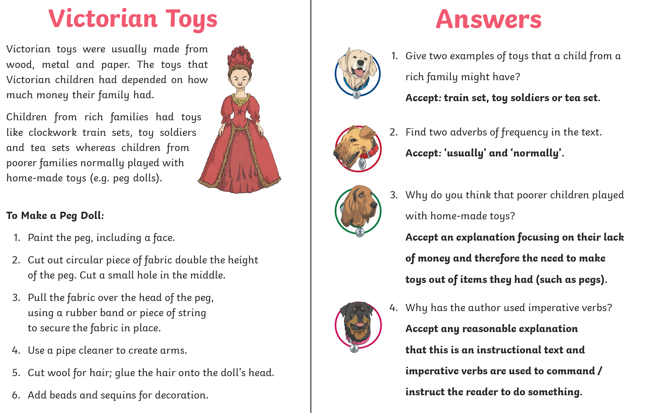



Maths:

Flashback 4!
What is the value of the Roman numeral? 107

- 6405 – 3284 = 3121

- 25% of 400 = 100

- 10000 – 150 = 9850
Maths

- 25 x 31 = 775

Science:





