Home Learning - ANSWERS
Year 5 – Summer Term 5 Week 1
20th April 2020
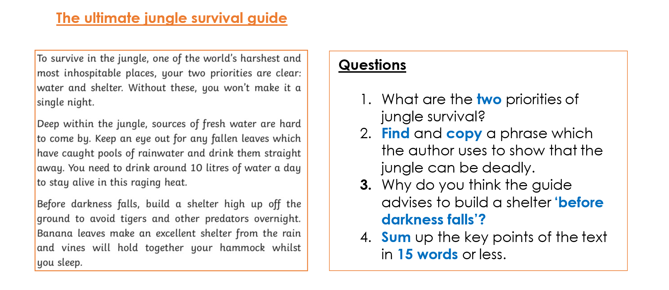
Comprehension:
ANSWERS
- Water and shelter.
- “One of the world’s harshest and most inhospitable places,” or “Without these, you won’t make it a single night,” or “Sources of fresh water are hard to come by,” or “You need to drink around 10 litres of water a day to stay alive in this raging heat,” or “build a shelter high up off the ground to avoid tigers and other predators overnight.”
- Own ideas – this could be to avoid tigers and other predators or other sensible suggestions such as “To be able to see what you are doing before the light has gone.”
- Own answers for example – “To survive in the jungle you need to find water and make a shelter.”

English:
Grammar – expanded noun phrases
Have a go at the questions below; can you identify the noun phrases in each?
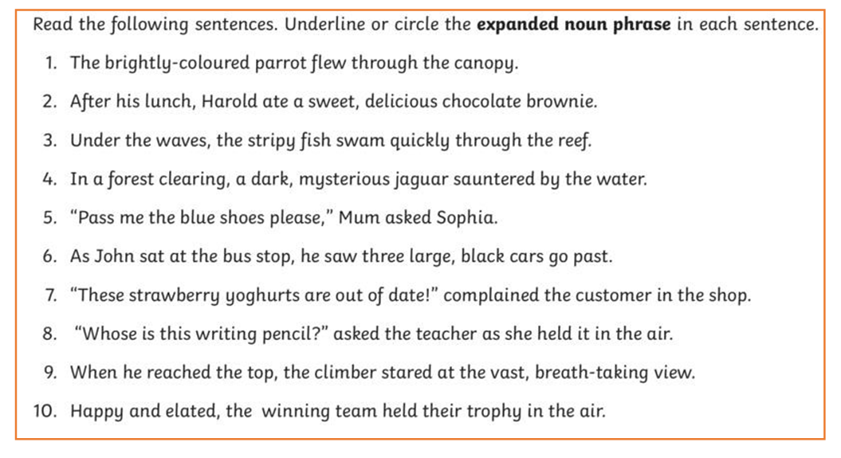



Maths:
Do you know what this shape is called?
Maths

Flashback 4!
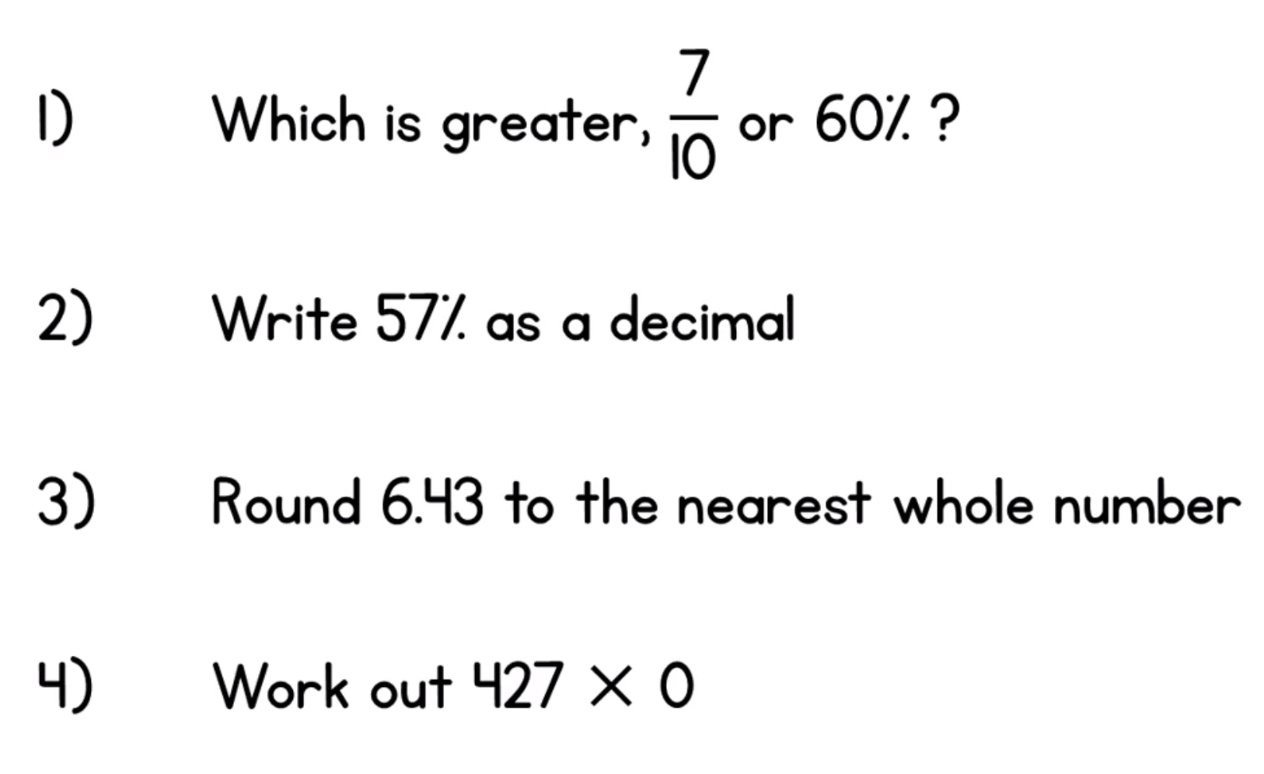
rhombus
7/10

0
6
0.57

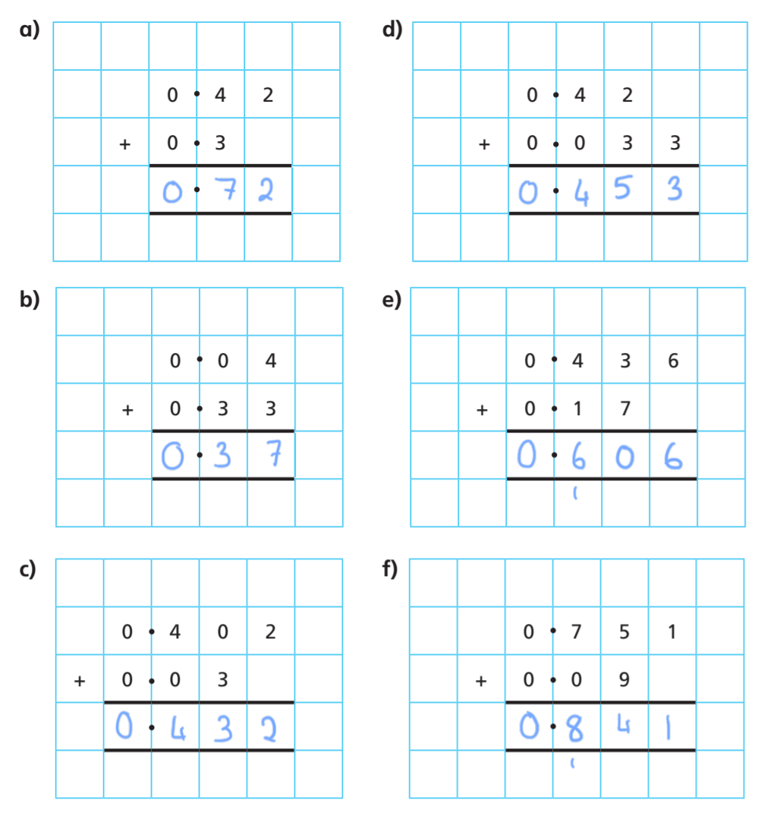

Science:
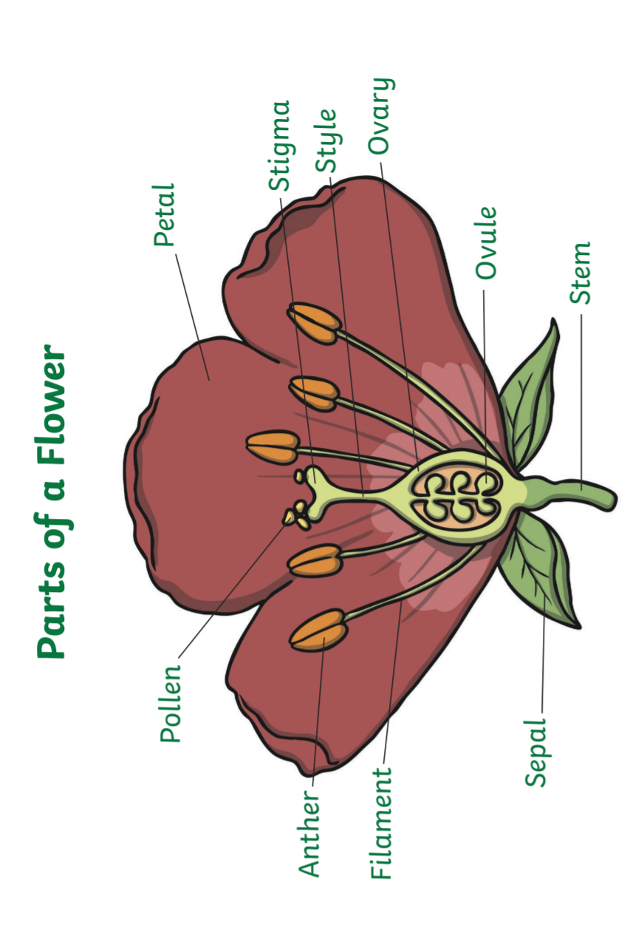

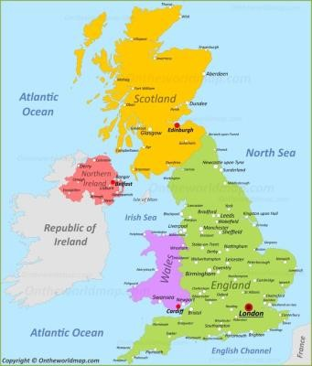
Geography:
- Research and find out the names of the countries within the UK. England, Scotland, Wales and Northern Ireland
- Do you know the name of the village, town or city you live in?
- What country do you live in? England
- How many cities are there in England? Can you name 10? There are 51 cities in England

Languages:
- Can you write down the days of the week in French? Can you then teach someone in your home how to say these words?
Lundi - Monday.
Mardi - Tuesday.
Mercredi - Wednesday.
Jeudi - Thursday.
Vendredi - Friday.
Samedi - Saturday.
Dimanche - Sunday

