Home Learning
Year 5 – Summer Term 5 Week 2 - ANSWERS
27th April 2020
Comprehension:
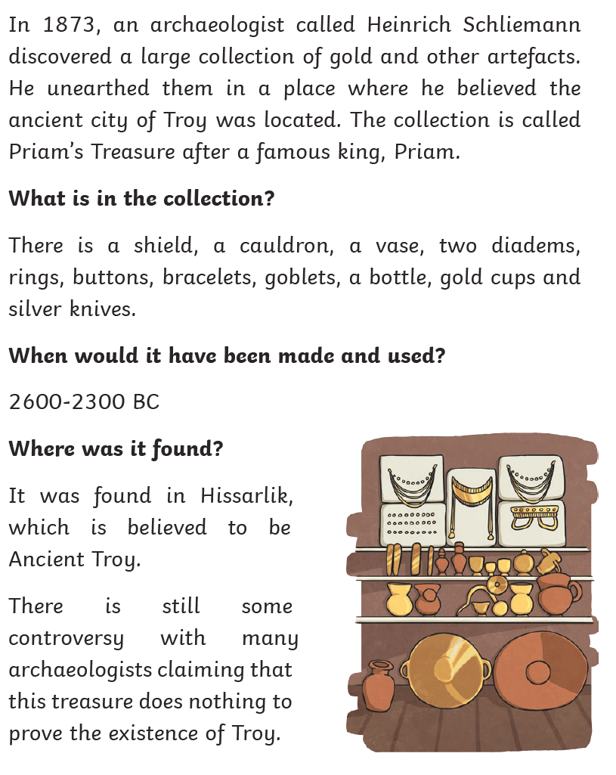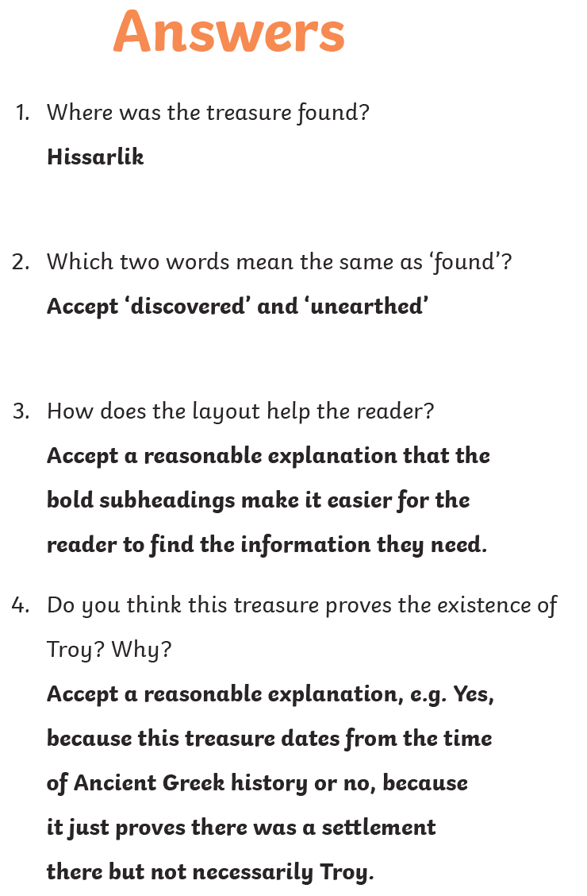

English:
Grammar –
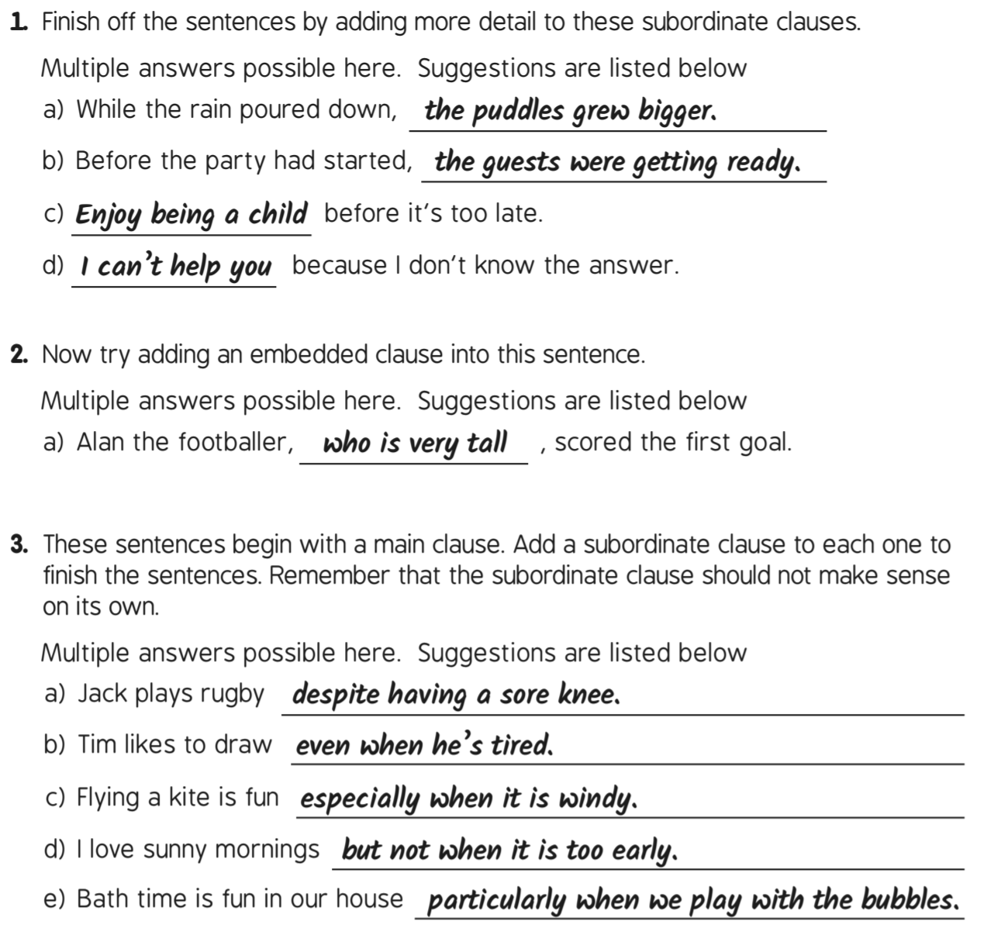


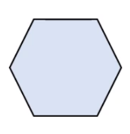
Maths:
Maths

Do you know what this shape is called?
Flashback 4!
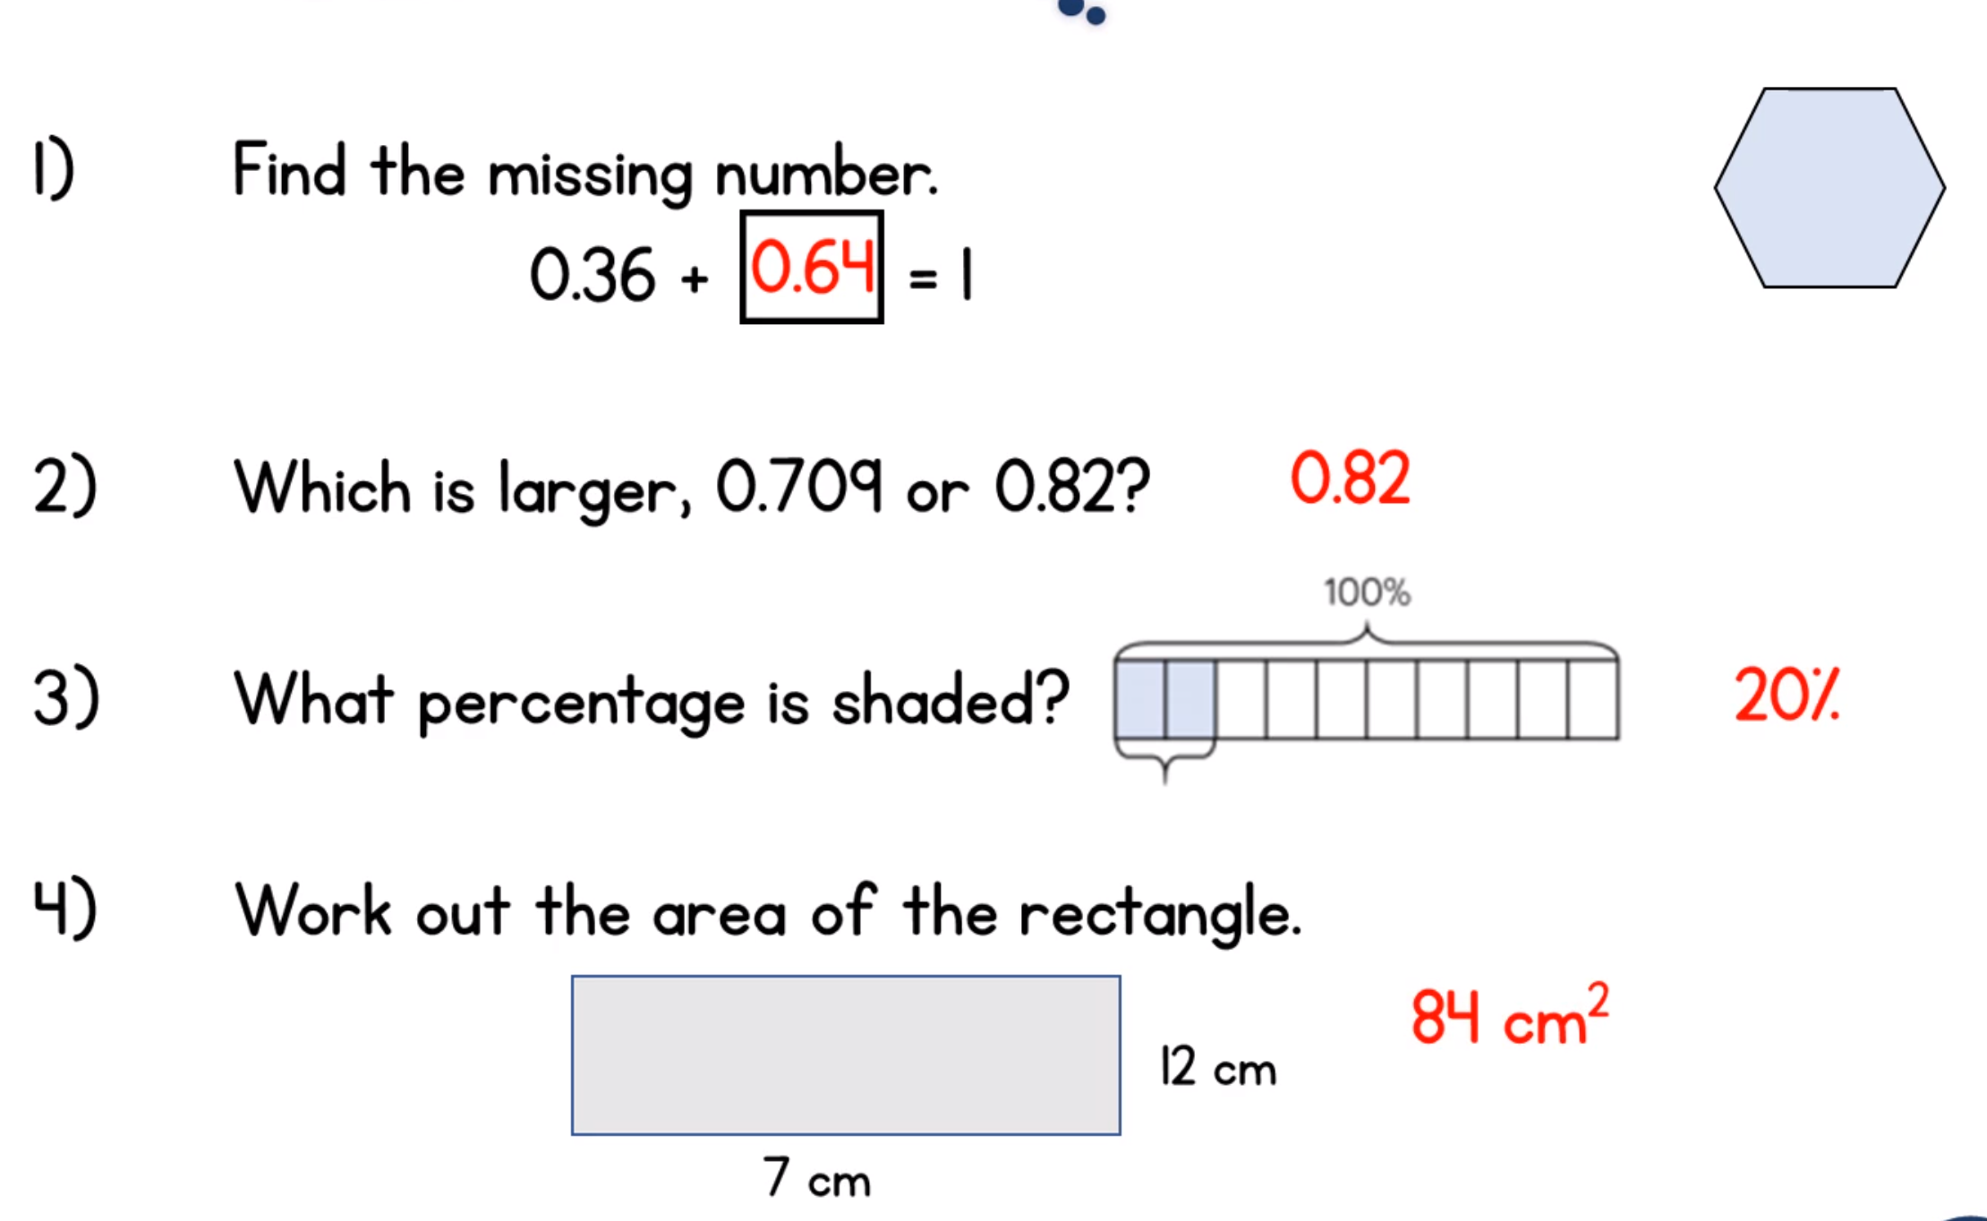
Hexagon

WRH Sumer Term Week 2 - Adding and Subtracting Decimals
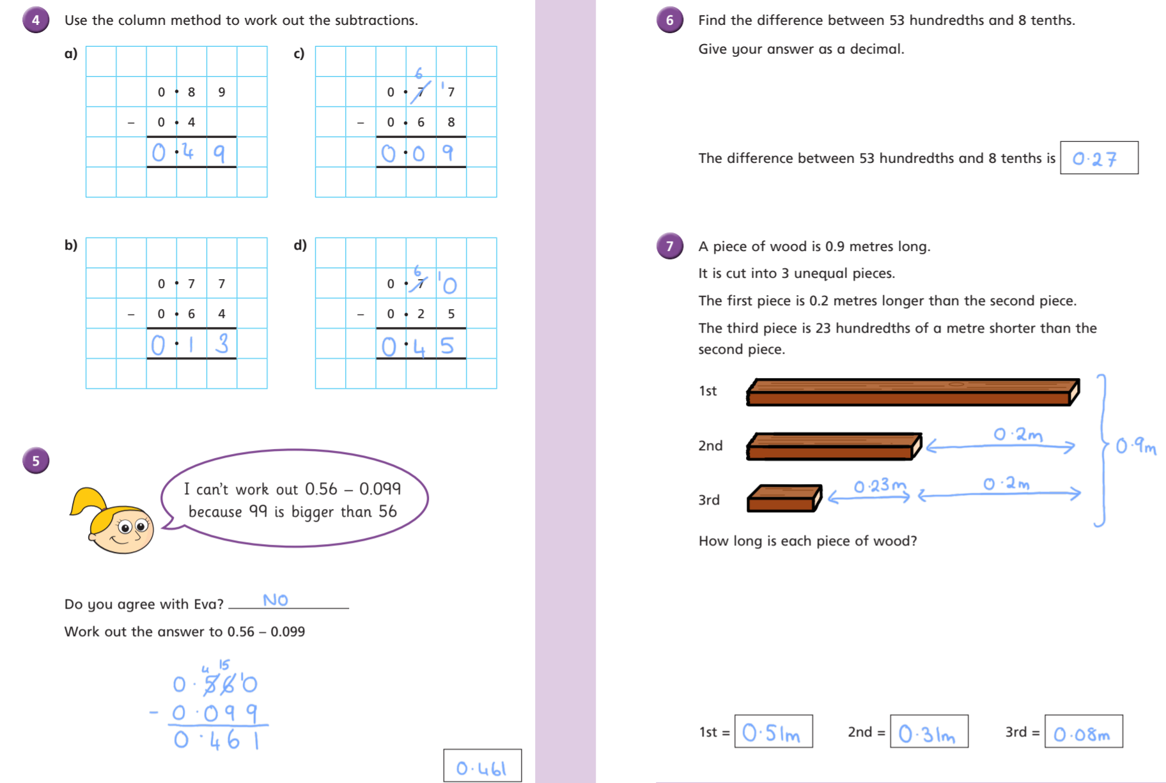

Geography:


