Home Learning
Year 5 – Summer Term 5 Week 3
4th May 2020

English

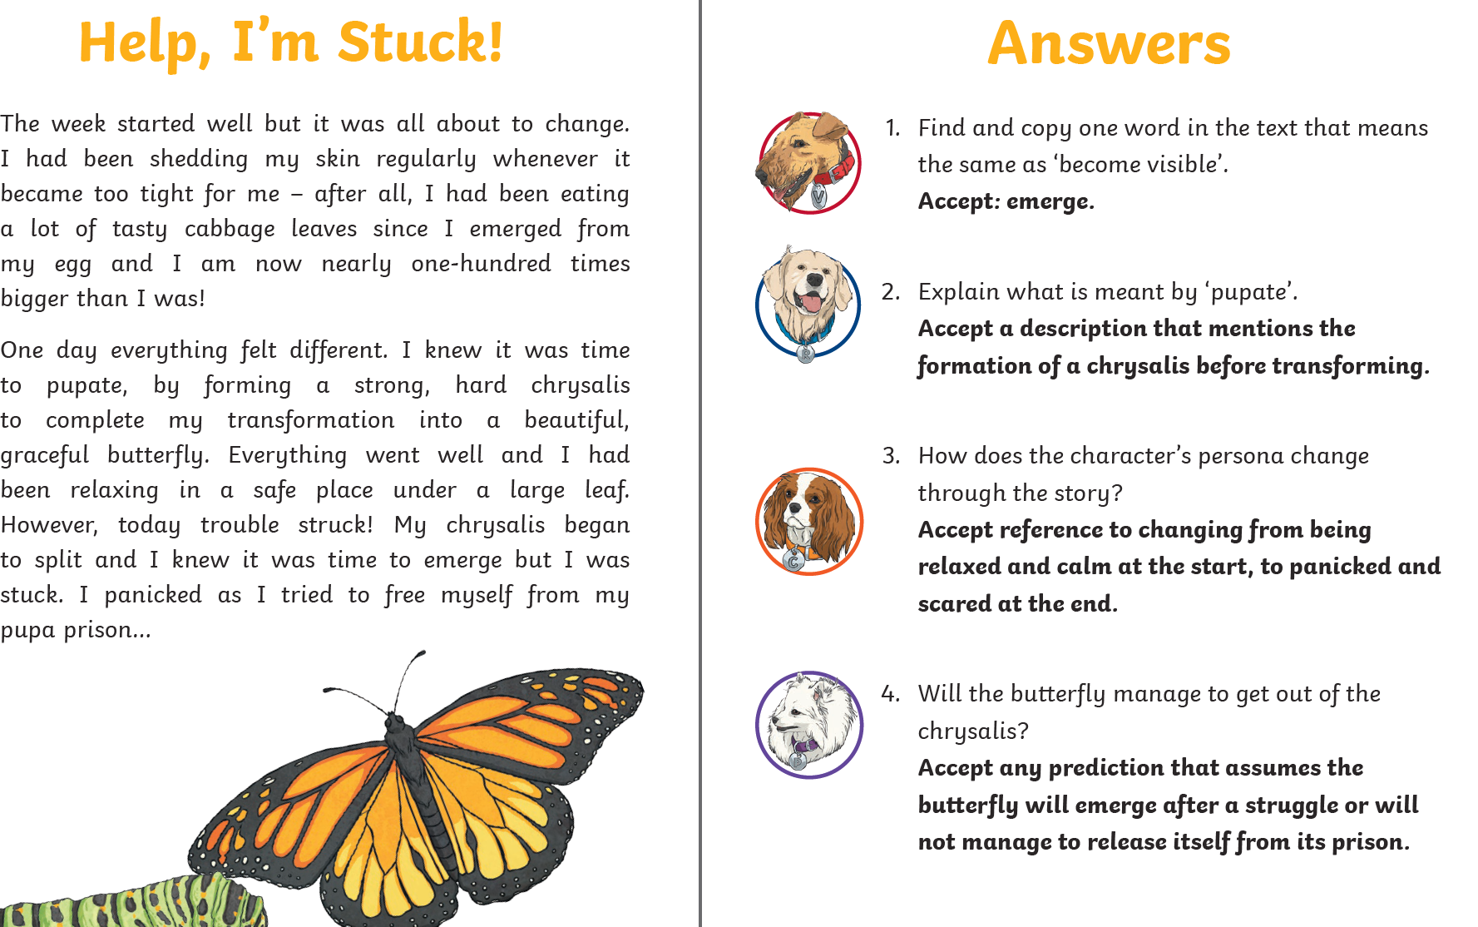

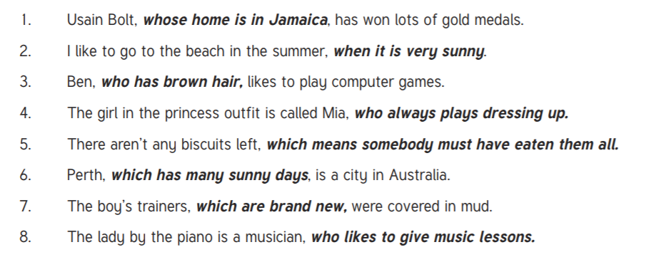

.

The time on the clock is 4:15 or quarter past 4.
Maths
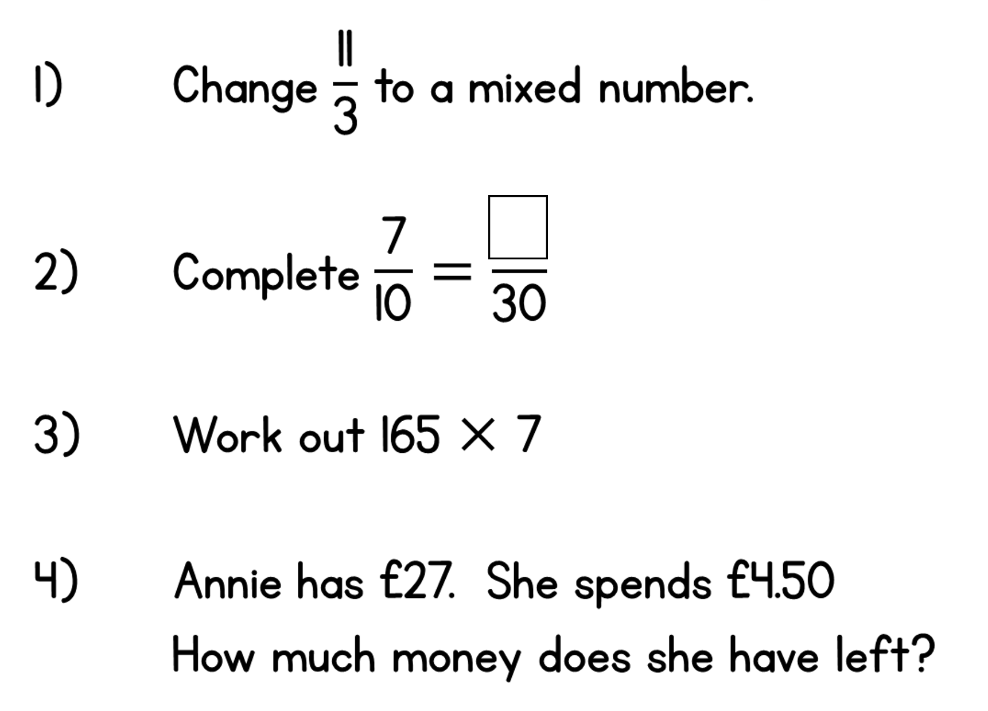
£22.50
1155
21
3 ⅔

Science:
If you completed the poster or powerpoint to explain all about metamorphosis, perhaps you could send it to me so that I can have a look.
History:
Well done if you completed the questions about Mayan religion and Gods. Your answers will be your own thoughts and opinions. Perhaps you completed the tasks to make a fact file about Mayan Gods. I would love to see some of your ideas and writing if you completed this task.

Geography:
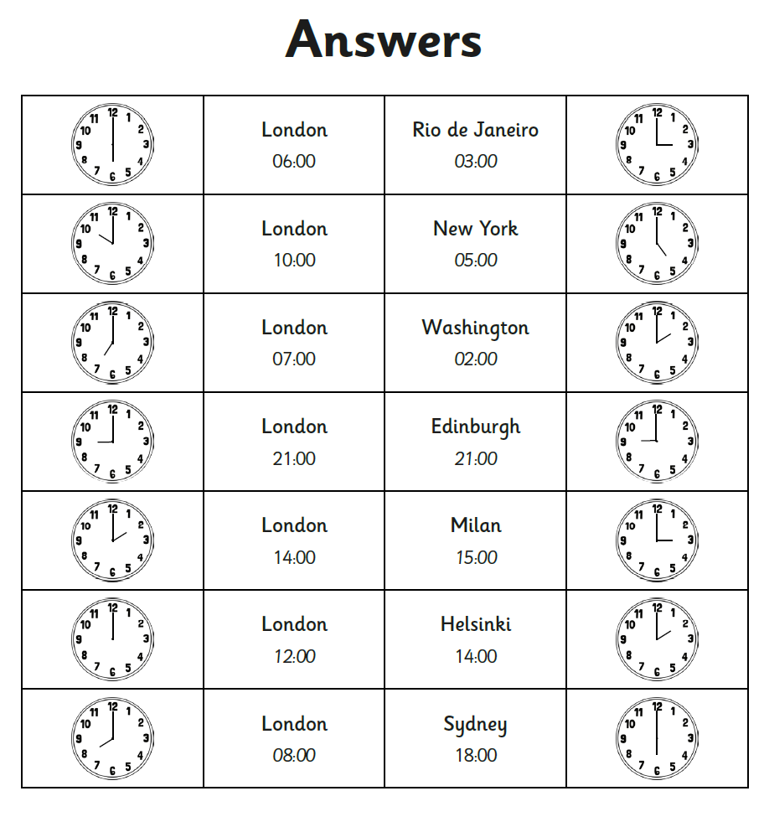

DT:
I would love to see your creations so please send me a photograph if you choose to take up the DT challenge to make your own chess or draughts set.

RE:
Can you find out more about the liturgies on Holy Thursday, Good Friday and Holy Saturday, answering these questions?
What is another name for Holy Thursday? Maundy Thursday, Covenant Thursday, Great and Holy Thursday, Sheer Thursday, and Thursday of Mysteries,
What is remembered during the mass on Holy Thursday? Why? The Mass of the Lord's Supper, also known as A Service of Worship for Maundy Thursday, is a Holy Week service celebrated on the evening of Maundy Thursday. It inaugurates the Easter Triduum, and commemorates the Last Supper of Jesus with his disciples.
What does the priest traditionally do during this mass? What is the meaning of this? The Priest strips and washes the alter – cleansing, a symbol of baptism
What is special about how the mass ‘ends’ on Holy Thursday? There is the Adoration of the Blessed Sacrament by the people during the night, just as the disciples stayed with the Lord during His agony on the Mount of Olives before the betrayal by Judas.
What is remembered during the service on Good Friday? Good Friday is the day on which Catholic and other Christian religions commemorate the crucifixion of Jesus Christ.
The service on Good Friday is not a ‘mass’ as such. Can you explain why? Good Friday is a day of fasting within the Church. Traditionally, there is no Mass and no celebration of the Eucharist on Good Friday. A liturgy may still be performed and communion, if taken, comes from hosts consecrated on Holy Thursday. Baptism, penance, and anointing of the sick may be performed, but only in unusual circumstances. Church bells are silent. Altars are left bare.
How does the Vigil service on Holy Saturday begin? What is the symbolism of this? The service begins outside the church. A new fire is lit and blessed. The candle is then processed through the church, with the deacon lifting the candle at three different times, singing: The Light of Christ. (or Lumen Christi) and the congregation sings in reply: Thanks be to God (or Deo gratias). Everyone lights their candle from the Easter candle and continue in procession until the whole church is alight. The Paschal candle symbolizes Christ, the Light of the World.

Many Christians are baptised following the mass, whilst others renew their baptismal promises. Why do you think this is? Own answers.

