Home Learning
Year 5 – Summer Term 5 Week 4
11th May 2020

English

Reading Comprehension

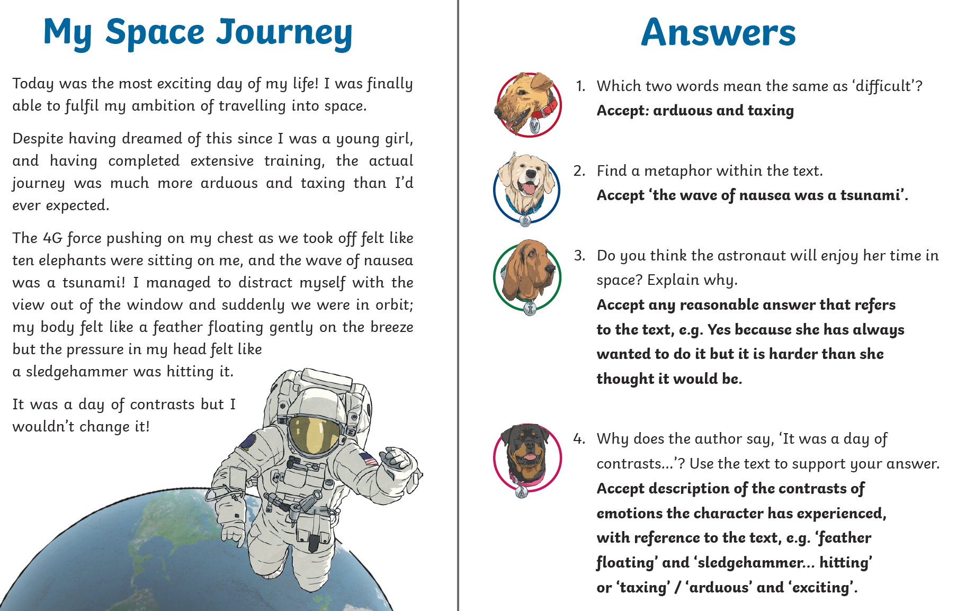

Grammar

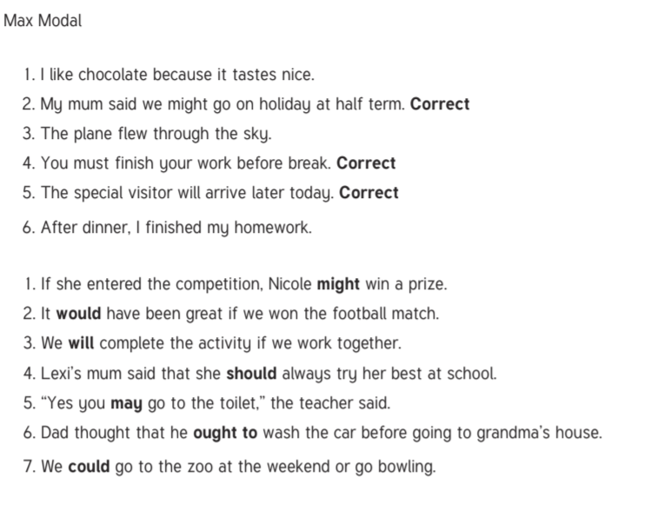


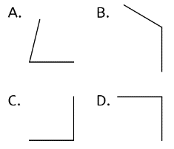
Maths:
Which shows an acute angle? A

Maths

Flashback 4!

- Work out 1342 + 862 2204

- Count backwards in steps of 2
4, 2, 0, … , … -2, -4

- What is a number that has factors of
only 1 and itself called? A prime number

- Round 1.14 to one decimal place 1.1

