Home Learning - ANSWERS
Year 5 – Summer Term 5 Week 5
18th May 2020

English

Reading Comprehension

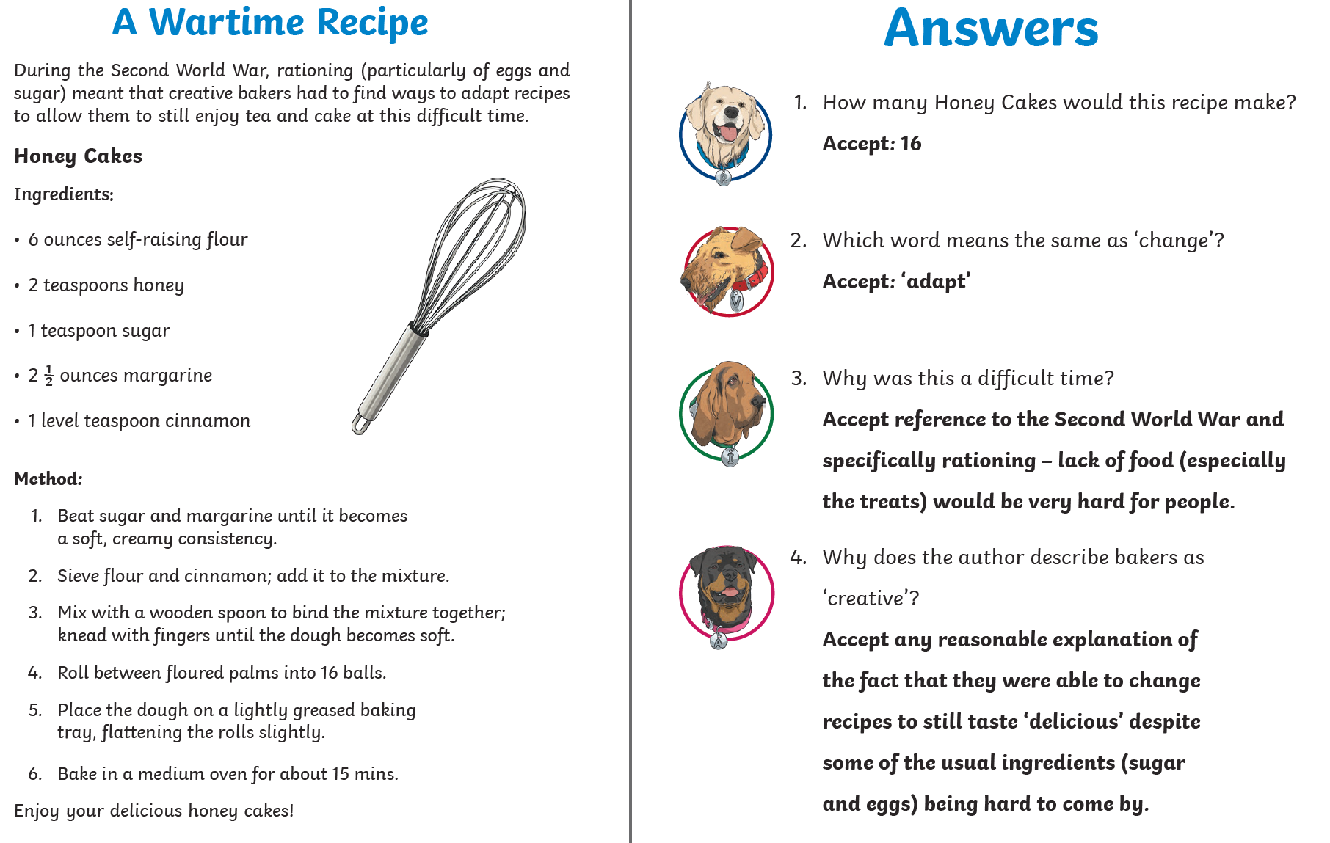

Grammar

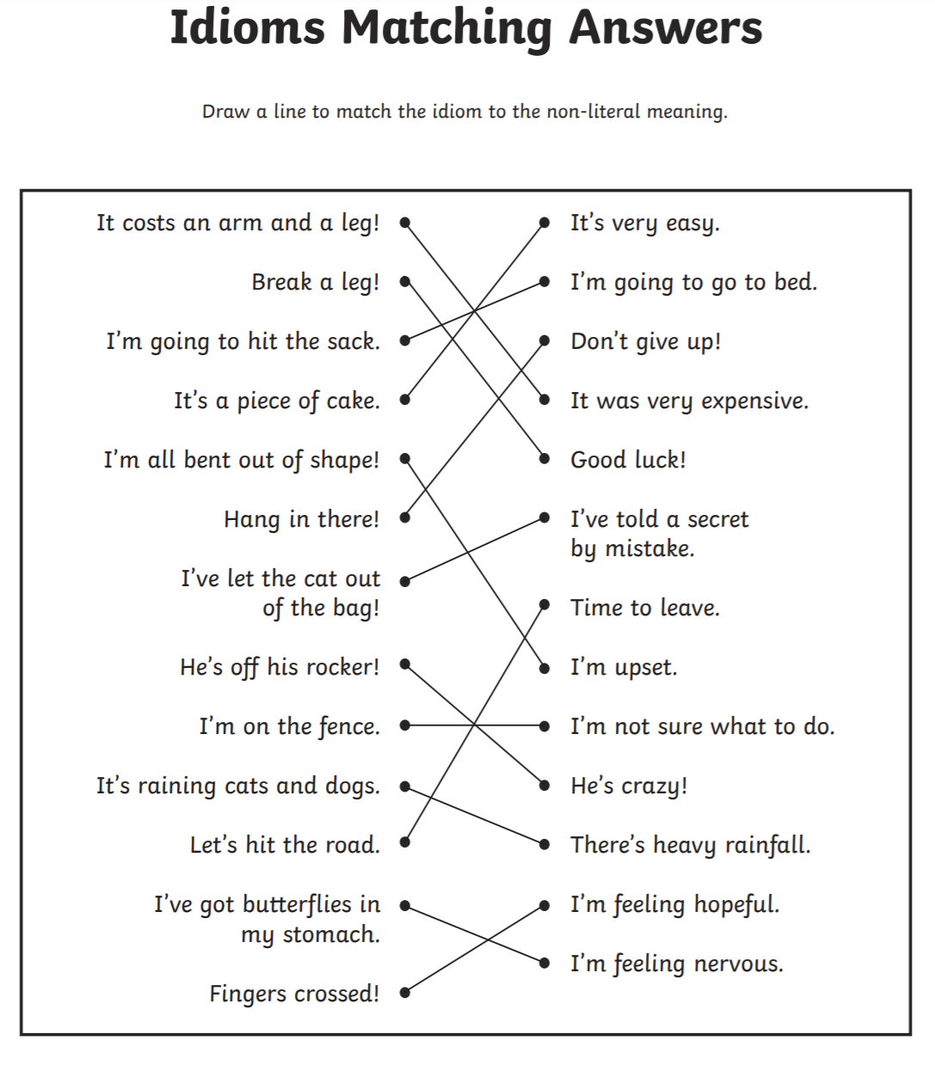

Maths:
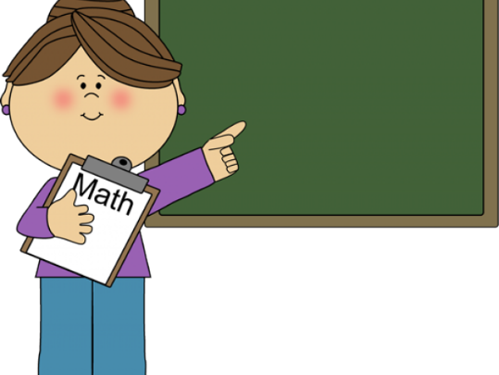
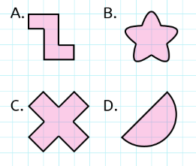
Flashback 4!
Which shape does NOT have any lines of symmetry? A

Maths

- 1342 + 862 = 2204

- 6 x 12 = 72

- 325 x 6 = 1950

- 5.18 – 2.74 = 2.44

